**FULL STACK DEVELOPMENT WITH MERN**

**MERN STACK BY MONGODB**

**PROJECT:**

**SHOPEZ: E-COMMERCE APPLICATION**

**Team Members**

**GAYATHRI R**

**LAKSHMI R**

**VAISHNAVI K G**

**HARINI K**

**1. INTRODUCTION**

* **Project Title:** ShopEZ: E-Commerce Application
* **Team Members:**

Gayathri R - Project Coordinator

Lakshmi R - Frontend Developer

Vaishnavi K G - Backend Developer

Harini K - Database Manager

**2. PROJECT OVERVIEW**

ShopEZ is a full-featured e-commerce platform aimed at providing a seamless shopping experience for users and efficient management tools for administrators. The platform allows customers to browse, filter, and purchase a diverse selection of products across categories like beauty, electronics, accessories, fashion, groceries, and stationery. Users can securely register, log in, and manage their profiles, with session handling enabled by JWT tokens and bcrypt-secure password hashing.

The MongoDB schema is designed to support a robust and scalable system, with collections for users, products, orders, carts and wishlist. Customers can add items to their cart, view product details with carousel images and discounted prices, and proceed to checkout. The admin dashboard provides administrators with tools to add and update products, view all users and orders, and monitor order status, ensuring efficient order management. The ShopEZ platform brings together essential e-commerce functionalities with a focus on a smooth user experience and effective administrative controls, making it a versatile tool for online retail.

**Purpose:**

The purpose of the ShopEZ e-commerce platform is to provide a seamless, secure, and enjoyable shopping experience while empowering both customers and administrators to efficiently manage their interactions and operations.

* **Enhancing Customer Experience**: ShopEZ offers users an intuitive platform where they can easily browse and purchase products, customize their shopping experience with filters, and manage their profiles and orders, all while ensuring convenience and accessibility.
* **Admin Control and Management:** The platform provides administrators with robust tools to manage users, products, and orders, giving them full control over the backend operations. Admins can update product listings, monitor order status, and maintain an organized user database for efficient platform management.
* **Promoting Secure Transactions:** ShopEZ leverages advanced security features such as JWT authentication and password hashing to ensure secure logins and data protection for users. Session handling further guarantees that users can maintain their login status across multiple tabs without compromising security.
* **Product Exploration and Customization:** The platform allows users to explore a wide variety of products across categories like beauty, electronics, fashion, and more. With filtering options and product customization features, customers can find exactly what they are looking for and make informed purchase decisions.
* **Fostering Convenience with Cart and Wishlist:** ShopEZ enhances the shopping experience by allowing customers to easily add items to their cart, manage quantities, and save favorite items in a wishlist. This ensures a personalized and efficient shopping journey, whether for immediate purchases or future considerations.
* **Cultural and Diverse Product Selection:** By offering a wide range of products across various categories and regions, ShopEZ promotes a diverse shopping experience that caters to different cultural preferences, tastes, and needs. This broad product variety ensures that customers can find items that resonate with their personal styles and requirements.

**Features:**

1. **User Authentication and Management**

ShopEZ uses JWT-based authentication for secure and reliable access control. This includes token encoding and decoding for session management, with password hashing implemented using bcrypt. Upon logging in, users are directed to their respective dashboards: customers to their profile page and admins to the admin dashboard. The system also supports "Forgot Password" functionality, where users can recover access without email verification, ensuring swift assistance. Additionally, the platform offers session handling with token expiry, allowing seamless multi-tab browsing with user details like name, email, type, and token stored securely.

1. **Customer Dashboard and Profile Management**

The Customer Dashboard and Profile Management feature in ShopEZ offers users an organized and user-friendly interface to manage their personal information, orders, cart, and wishlist. The dashboard displays essential details such as the customer’s name, email, and the status of their active, completed, and canceled orders, providing a convenient overview of their order history. Customers can also update their profile details to keep their information current. Additionally, the profile page includes access to the user's cart, where they can view and modify selected items, and the wishlist, where users can save their favorite products for future reference.

1. **Filtering Options**

A comprehensive catalog of products is provided to users, with filtering options by price, category, and gender, and the ability to clear filters for a more customized browsing experience. The platform supports a category-based organization, displaying products in popular categories like beauty products, electronics, accessories, fashion, groceries, and stationeries. Users can view each product’s details in a card format, including product name, description, price, and discount percentage. There is also an image carousel feature on each product card, enhancing visual engagement with a zoom-in functionality on hover.

1. **Product browsing**

The product browsing feature in the ShopEZ application includes an intuitive search bar that allows users to find items by entering keywords related to product names or categories. This search functionality quickly narrows down relevant products, enhancing navigation and helping users efficiently locate items that match their interests. Through this feature, users experience a simplified and targeted search process within the ShopEZ platform.

1. **Product Details and Cart Management**

Individual product pages offer an in-depth view with product name, detailed description, quantity, optional sizes, price (with original price, discount, and final price displayed), rating, and both "Buy Now" and "Add to Cart" options. Customers can easily add items to the cart or buy them directly. If a product comes in multiple sizes, a pop-up prompts users to select the desired size before adding it to the cart. Cart management is simplified by showing item details, quantity, and total price, along with a “Place Order” option for selected items. The cart also allows users to remove items or select products for calculating the final order price, creating an efficient shopping experience.

1. **Wishlist Functionality**

The wishlist feature allows users to save products for future purchases. Each wishlist entry is mapped to the corresponding product in the database, making it easy for users to access and add items from their wishlist directly to their cart. This feature is particularly useful for users who want to keep track of their preferred products and purchase them at a later date.

1. **Order Management**

Customers can view their active, completed, and canceled orders in their profile. Order details include essential information such as order status (placed, in-transit, delivered), payment method, order date, and delivery date. This organized approach to order tracking allows users to stay informed about the progress of their purchases and access their order history conveniently.

1. **Admin Dashboard and Functions**

The admin dashboard is a centralized control hub for managing users, products, and orders. Admins can access a list of all registered users, each user’s order count, and manage products with update functionality. The admin can also oversee all orders, with filters for different order statuses (placed, in-transit, delivered, canceled), making it easier to track and modify orders as needed. A product management page enables the admin to add new products with all necessary details, as specified in the product schema, ensuring inventory is always up-to-date.

**3. ARCHITECTURE**

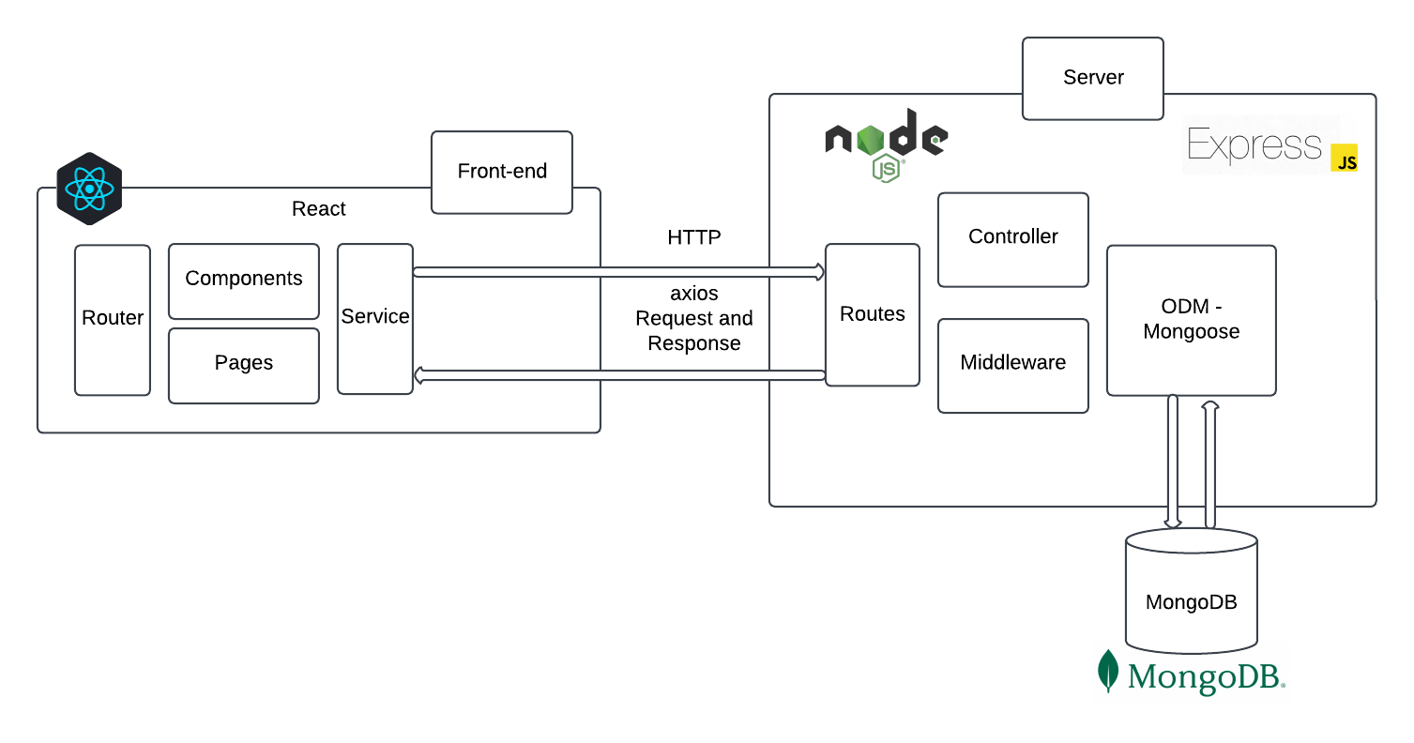

*Figure 1.Architecture*

**Frontend:**

The frontend is structured as a single-page application (SPA) using React. This architecture aims to deliver an interactive user experience, where various components dynamically load and update content without needing full page reloads.

* **Component Structure:**

Functional Components: All React components are structured as functional components for better performance and use of React hooks.

* **State Management:**

Context API, combined with custom hooks and reducers, is used for managing global state (e.g., user authentication, cart data, and filters). Session storage is used to store JWT tokens and user data to manage sessions across different tabs. Tokens are verified before making requests.

* **Routing:**

React Router: react-router-dom is used for client-side routing, with different routes for each main page and protected routes for user-specific and admin-specific pages.

* **API Communication:**

Axios is used for HTTP requests to communicate with the backend API. The JWT token is included in the header of each request to ensure secure access to protected routes. Centralized error handling with feedback for users, such as login failure, invalid inputs, or out-of-stock items.

* **Styling and UI:**

Styled components or inline styles are used for modular and scalable CSS. CSS media queries are used to ensure responsiveness across devices, particularly for product lists and the cart.

**Backend:**

The backend is built with Node.js and Express.js, providing a RESTful API for the frontend and managing user authentication, product data, and order processing.

* **Server Structure:**

The main application is built using Express which initializes all middleware, routes, and database connections. Environment Configuration is done using dotenv and is used to manage environment variables like database URI, JWT secret, and server port.

* **API Design:**
  + RESTful Endpoints: CRUD operations for Users, Products, Orders, and Cart items.
  + Route Modules: Routes are modularized for each entity (e.g., authRoutes, productRoutes, orderRoutes, userRoutes) for better organization.
  + Middlewares:
  + JWT Middleware: Validates tokens for protected routes to ensure only authenticated users can access restricted endpoints. Centralized error handling to manage all types of server-side errors. express-validator is used for validating user inputs, such as registration and login fields.
* **Authentication and Authorization:**
  + JSON Web Tokens are used for secure access, generated on login and verified on protected routes. bcrypt is used to hash user passwords before storing them in the database.
  + Role-Based Access Control functions are used to control access for Customer and Admin roles, allowing only admins to access certain endpoints.
* **Session and Token Handling:**

Tokens have an expiry time, after which users need to log in again. The token, user ID, and user type are stored in the frontend session storage for identifying the logged-in user across pages.

**Database:**

The database uses MongoDB with a schema defined through Mongoose. Collections are created to manage Users, Products, Orders, and Cart items, ensuring data integrity and efficient querying.

**Database Structure:**

**i) User Schema:**

* **Fields:** username, password (hashed), email, and usertype.
* **Indexes:** Unique indexes on username and email to prevent duplicates.
* **Relationships:** User IDs are referenced in the Orders and Cart collections.

**ii) Product Schema:**

* **Fields:** title, description, mainImg, carousel, sizes, category, gender, price, and discount.
* **Indexes:** Indexed by title and category for efficient searching and filtering.
* **Relationships:** Products are referenced in the Cart and Orders collections.

**iii) Order Schema:**

* **Fields:** userId, products (array of product details), address, orderDate, deliveryDate, paymentMethod, and orderStatus.
* **Relationships:** userId references the User collection, and each product entry contains a reference to the Product collection.

**iv) Cart Schema:**

* **Fields:** userId, productId, quantity, price, and discount.
* **Relationships:** Each cart item references userId and productId for a relational link to the User and Product collections.
* **Constraints:** Ensure uniqueness of the userId and productId combination to avoid duplicate cart entries.

**v) Wishlist Schema:**

* **Fields**: userId, productId.
* **Relationships:** userId and productId as foreign keys referencing the User and Product collections.
* **Constraints:** Ensure uniqueness of userId and productId pairs for each wishlist entry.

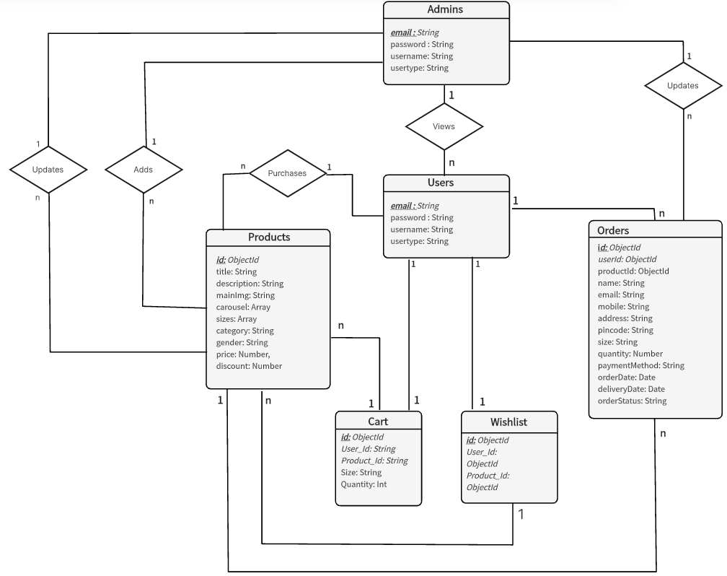

*Figure 2.ERD Diagram*

**Database Operations:**

The database layer of ShopEZ is powered by MongoDB and is designed in a way to perform efficient data operations on users, products, orders, carts, and wishlists. The typical operations inside the database include CRUD operations, that is Create, Read, Update, and Delete. Create operations add new entries to collections, such as adding a new product, registering a user, or saving an item to a wishlist. Read operations retrieve information, enabling features like displaying product details, fetching cart items, and listing past orders. Update operations modify existing entries, which is essential for tasks like updating product inventory, changing order statuses, or editing user profiles. Delete operations remove data, allowing users to clear items from their cart or wishlist and admins to manage outdated products.

**4. SETUP INSTRUCTIONS**

To set up the ShopEZ e-commerce application, follow these steps:

**1. Install Prerequisites:**

* **Node.js (Version 20.x):** Download and install from Node.js official website, which includes npm (Node Package Manager).
* **MongoDB:** Set up MongoDB using MongoDB Compass for a local instance or create a MongoDB Atlas account for a cloud-based setup.
* **Git:** Install Git from Git downloads for version control.
* **npm -** Node Package Manager (comes with Node.js).
* **Code Editor -** Visual Studio Code or another preferred IDE.

**2. Download Project Files:**

Place all project files in a dedicated project directory on the local machine.

**3. Install Dependencies:**

Open a terminal, navigate to the project directory, and install the required dependencies:

*npm install*

**4. Set Up Environment Variables:**

In the project root, create a .env file to store environment-specific variables such as database connection strings and JWT secrets. Contents in the .env file is as follows:

PORT=3001

MONGO_URI=<mongodb-connection-string>

JWT_SECRET=<jwt-secret>

**5. Run the Application:**

Start the application in development mode:

*npm start*

Now the application can be accessed locally at http://localhost:3000.

**5. FOLDER STRUCTURE**

The ShopEZ e-commerce application follows a well-organized folder structure for both the **Frontend** (React) and **Backend** (Node.js) to ensure clarity, scalability, and maintainability of the project.

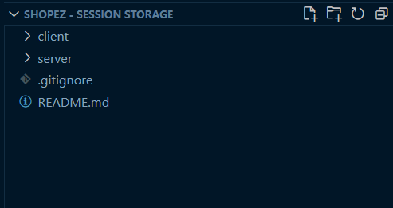

*Figure 3.Overall Folder Structure*

**Client: React Frontend Structure**

The frontend of ShopEZ is built using **React**, and its folder structure is organized as follows:

* **public/**:
  + Contains static assets like the index.html file, favicon, and other public files that are served directly to the browser.
* **src/**:
  + This is where all the source code of the React application resides.
  + **components/**: Contains reusable components such as the header, footer, product card, cart items, etc. These components are used throughout the application.
  + **pages/**: Contains React components that represent different pages in the application, such as Home, ProductDetails, Cart, Profile, etc.
  + **context/**: Handles the global state management for the app using React Context API. This includes user authentication and cart state management.
  + **styles/**: Contains custom CSS files to style the components and pages, ensuring the application's design is modular and maintainable.
  + **images/**: Stores image assets like product images, and icons used throughout the application, centralizing all visual elements for easy management.
  + **App.js**: The root component where routing and major layout structures are defined.
  + **index.js**: Entry point of the application where ReactDOM renders the app into the DOM.
* **package.json**:
  + This file manages project dependencies, scripts, and other configurations for the frontend application.

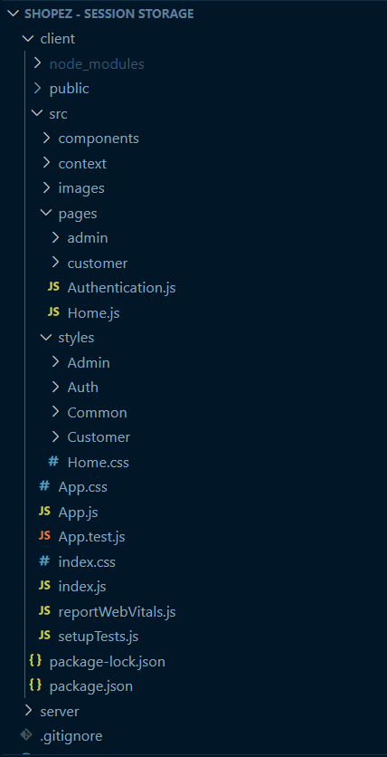

*Figure 3.1 Client Structure*

**Server: Node.js Backend Structure**

The backend of ShopEZ is built using **Node.js** and follows a simple but effective folder structure for API development:

* **models/**:
  + Contains the Mongoose models for interacting with the MongoDB database. For example, User.js, Product.js, Order.js, etc., define the schema for respective entities in the database.
* **routes/**:
  + Houses route files where the API endpoints are defined. For example, userRoutes.js handles user authentication routes, productRoutes.js manages product-related endpoints, and orderRoutes.js handles order processing.
* **middleware/**:
  + Includes middleware functions used in the application. For example, authMiddleware.js verifies the JWT token for protected routes, and errorHandler.js handles errors globally throughout the backend.
* **index.js**:
  + The entry point of the backend application where the Express server is set up, middleware is applied, and routes are initialized.
* **package.json**:
  + This file manages backend dependencies and includes scripts for running the server.

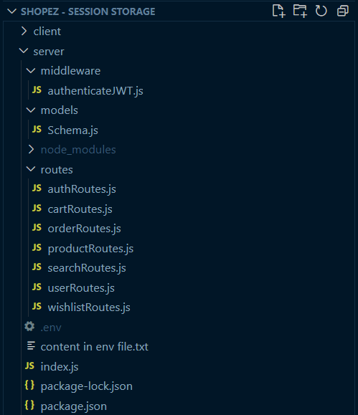

*Figure 3.2.Server Structure*

**6. RUNNING THE APPLICATION**

To run the ShopEZ e-commerce application locally, the following steps are done for starting both the frontend and backend servers:

**Frontend:**

**1. Navigate to the Client Directory:**

Open a terminal window on your system.

Use the cd (change directory) command to navigate to the client folder, which contains all the frontend code for the application.

*cd C:\Users\ShopEZ\client*

**2. Install Frontend Dependencies:**

Before starting the frontend server, ensure that all required dependencies are installed. If this is the first time running the project or if dependencies have been added or updated, run the following command to install them:

npm install

This command will install all the necessary packages listed in the package.json file, including React and other dependencies.

**3. Start the Frontend Server:**

After installing the dependencies, use the following command to start the React development server:

npm start

This will compile the React application and start a local development server.

**4. Access the Application:**

* Once the server is running, a web browser is opened and goes to http://localhost:3001.
* The frontend application will be accessible at this URL, and you should see the ShopEZ user interface in your browser. The frontend is now live and connected to the backend server for full functionality.

**Backend:**

**1. Navigate to the Server Directory:**

Open a terminal window.

Use the cd (change directory) command to navigate to the server folder, which contains all the backend code for the application.

cd C:\Users\ShopEZ\server

**2. Install Backend Dependencies:**

If this is the first time running the backend server, ensure all required dependencies are installed by running:

npm install

This will install all the necessary backend packages, including Express, Mongoose, and other dependencies as specified in the package.json file.

**3. Start the Backend Server:**

Once the dependencies are installed, use the following command to start the backend server:

node index.js

This will initialize the backend server and connect it to the database.

**4. Access the Backend:**

* The backend server will now be running and can be accessed via http://localhost:3001.
* This URL is used to handle all API requests, and the backend will process interactions such as user authentication, product management, and order processing.

**7. API DOCUMENTATION**

The ShopEZ backend exposes various endpoints to handle operations related to products, users, orders, and authentication.

**1. Authentication**

* **POST /api/user/register**

**Description:** Registers a new user.

**Request Body:**

{

"username": "yyyy",

"email": "yyyy@gmail.com",

"password": "yyyy12345",

"usertype": "customer"

}

Response:

200 OK: User registration successful with user details.

400 Bad Request : Invalid or missing parameters.

* **POST /api/user/login**

**Description:** Logs in a user and generates a JWT token for authorization.

**Request Body:**

{

"email": "aaa@gmail.co",

"password": "aaa123"

}

**Response:**

200 OK: Returns a JWT token.

401 Unauthorized: Invalid credentials.

* **POST /api/forgot/forgot-password**

**Description:** Sends a password reset link to the user's email.

**Request Body:**

{

"email": "dfdfd@gmail.com"

}

**Response:**

200 OK: Password reset link sent successfully.

400 Bad Request: Email not found in the system.

**2. User Management**

* **GET /api/users**

**Description:** Retrieves a list of all users in the system.

**Response:** 200 OK: Returns an array of all users.

[ {

"userId": "xxxxxxxxxxxxxxx",

"username": "aaa",

"email": "aaa@gmail.com",

"usertype": "customer"

},

{

"userId": "xxxxxxxxxxxxxxx",

"username": "dfdfd",

"email": "dfdfd@gmail.com",

"usertype": "customer"

},

{

"userId": "xxxxxxxxxxxxxxx",

"username": "bbb",

"email": "bbb@yahoo.com",

"usertype": "admin"

} ]

**3. Product Management**

* **GET /api/products/fetch-products**

**Description:** Retrieves a list of all products with optional filtering by category, price range, and gender.

**Query Parameters:** category, priceMin, priceMax, gender

**Response:** 200 OK: Returns an array of products.

[ {

"title": "Sony Wireless Headphones",

"description": "Sony WH-CH520 | White | Wireless Over-Ear Active Noise Cancellation Headphones with Mic | Multi-Point Connection",

"mainImg": "<main-img-url>",

"sizes":[],

"category":"Electronics",

"price": 7399,

"discount": 16,

} ]

* **GET /api/products/fetch-products/:id**

**Description:** Retrieves details of a specific product by its ID.

**Path Parameter:** id

**Response:** 200 OK: Returns detailed information of the product.

{

"title": "Casual Fit Shirt",

"description": "Lightweight white half-hand shirt | Regular Fit | Spread Collar Casual",

"mainImg": "<main-img-url>",

"sizes":[],

"category":"Fashion",

"price": 1299,

"discount": 45,

}

* **POST /api/products/**

**Description:** Add new product.

**Request Body:**

{

"title": "Casual Fit Shirt",

"description": "Lightweight white half-hand shirt | Regular Fit | Spread Collar Casual",

"mainImg": "<main-img-url>",

"carousel": Array of image url,

"sizes":[],

"category":"Fashion",

"price": 1299,

"discount": 45,

}

**Response:** 200 OK: Returns detailed information of the product.

{

"_id": "xxxxxxxxxxxx",

"title": "Casual Fit Shirt",

"description": "Lightweight white half-hand shirt | Regular Fit | Spread Collar Casual",

"mainImg": "<main-img-url>",

"sizes":[],

"category":"Fashion",

"price": 1299,

"discount": 45,

}

* **PUT /api/products/update-product/:id**

**Description:** Update details of existing products

**Request Body:**

{

"title": "Casual Fit Shirt",

"description": "Lightweight white half-hand shirt | Regular Fit | Spread Collar Casual",

"mainImg": "<main-img-url>",

"carousel": Array of image url,

"sizes":[],

"category":"Fashion",

"price": 1500,

"discount": 45,

}

**Response:** 200 OK: Returns detailed information of the product.

{

"_id": "xxxxxxxxxxxx",

"title": "Casual Fit Shirt",

"description": "Lightweight white half-hand shirt | Regular Fit | Spread Collar Casual",

"mainImg": "<main-img-url>",

"sizes":[],

"category":"Fashion",

"price": 1500,

"discount": 45,

}

* **GET /api/products/fetch-categories**

**Description:** Fetches all the product categories.

**Response:** 200 OK: Returns all the available categories.

{

[

"Accessories",

"Beauty Products",

"Electronics",

"Fashion",

"Groceries",

"Stationeries"

]

}

**4. Cart Management**

* **POST /api/cart/add-to-cart**

**Description:** Adds an item to the user's cart.

**Request Body:**

{

"userId": "xxxxxxxxxxxx",

"productId": "xxxxxxxxxxxxx",

"quantity": 2

}

**Response:** 200 OK: Successfully added product to cart.

{

"message": "Product added to cart",

"cartItem": {

"productId": "xxxxxxxxxxxx",

"quantity": 2

}

}

* **GET /api/cart/fetch-cart**

**Description:** Retrieves all items in the user's cart.

**Path Parameter:** userId

**Response:** 200 OK: Returns a list of cart items.

[ {

"productId": "xxxxxxxxxxx",

"quantity": 1,

"price": 220

} ]

* **PUT /api/cart/increase-cart-quantity**

**Description:** Increases the quantity of a specific cart item by 1.

**Request Body:**

{

"id": "xxxxxxxxxxxx"

}

**Response**: 200 OK

{

"productId": "xxxxxxxxxxxx",

"quantity": 3

}

* **PUT /api/cart/decrease-cart-quantity**

**Description:** Decreases the quantity of a specific cart item by 1. If quantity reaches 0, the item is removed from the cart.

**Request Body:**

{

"id": "xxxxxxxxxxxx"

}

**Response:** 200 OK

Response Body (if quantity is greater than 1):

{

"productId": "xxxxxxxxxxxx",

"quantity": 1

}

Response Body (if item is removed):

{

"message": "Item removed from cart"

}

* **DELETE /api/cart/**

**Description:** Removes a specific item from the user's cart.

**Path Parameter**: id - ID of the cart item to be removed

**Response:** 200 OK

{

"message": "Item removed from cart",

"deletedItem": {

"productId": "xxxxxxxxxxxx",

"quantity": 1

}

}

* **POST /api/cart/place-cart-order**

**Description:** Places an order for selected items in the user's cart.

**Request Body:**

{

"userId": "xxxxxxxxxxxx",

"items": [

{ "productId": "xxxxxxxxxxxx", "quantity": 2 }

],

"name": "user1",

"mobile": "9876590879",

"email": "user1@mail.com",

"address": "ccc",

"pincode": "300003",

"paymentMethod": "Credit Card",

"orderDate": "2024-11-14"

}

**Response:** 200 OK

{

"message": "Order placed successfully for selected items."

}

**5. Order Management**

* **POST /api/order/buy-product**

**Description:** Places a new order.

**Request Body:**

{

"userId": "xxxxxxxxxxxxx",

"cartItems": [ {

"productId": "xxxxxxxxxxx",

"quantity": 1

} ],

"address": "12 St, rrrr",

"pincode": "100001"

"paymentMethod": "Credit Card",

}

**Response:** 200 OK: Order successfully placed.

{

"message": "Order placed successfully",

"order": {

"orderId": "xxxxxxxxxxxx",

"status": "Order placed"

} }

* **GET /api/order/fetch-orders**

**Description:** Retrieves all orders for a specific user.

**Path Parameter:** userId

**Response:** 200 OK: Returns a list of orders.

[ {

"orderId": "xxxxxxxxxxxxx",

"status": "Order placed",

"price": 1350

} ]

* **GET /api/order/**

**Description:** Retrieves all orders placed by a specific user.

**Path Parameter:** id - ID of the user whose orders are to be fetched

**Response:** 200 OK

[

{

"userId": "xxxxxxxxxxxx",

"title": "Product Title",

"quantity": 2,

"price": 220,

"orderStatus": "Pending"

}

]

* **PUT /api/order/update-order-status**

**Description:** Updates the status of a specified order.

**Request Body:**

{

"id": "xxxxxxxxxxxx",

"updateStatus": "Shipped"

}

**Response:** 200 OK

{

"message": "Order status updated"

}

* **DELETE /api/order/**

**Description:** Deletes a specific order.

**Path Parameter:** id - ID of the order to be deleted

**Response:** 200 OK

{

"message": "Order deleted successfully",

"deletedOrder": {

"userId": "xxxxxxxxxxxx",

"title": "Product Title",

"quantity": 2

}

}

* **PUT /api/order/cancel-order**

**Description:** Cancels a specified order by changing its status to "cancelled".

**Request Body:**

{

"id": "xxxxxxxxxxxx"

}

**Response:** 200 OK

{

"message": "Order cancelled successfully"

}

**6. Wishlist Management**

* **POST /api/wishlist/:userId/add**

**Description:** Adds an item to the user's wishlist.

**Request Body:**

{

"userId": "xxxxxxxxxxx",

"productId": "xxxxxxxxxxxxxx"

}

**Response:** 200 OK: Successfully added product to wishlist.

{

"message": "Product added to wishlist",

"wishlistItem": {

"productId": "xxxxxxxxxxxxxxxx"

}

}

* **GET /api/wishlist/:userId**

**Description**: Retrieves all items in the user's wishlist.

**Path Parameter:** userId

**Response:** 200 OK: Returns a list of wishlist items.

[ {

"productId": "xxxxxxxxxxxxxxxxx",

"title": "Pilgrim Matte Lipstick",

"price": 250

} ]

* **POST /api/wishlist/remove**

**Description:** Removes a product from a user's wishlist.

**Path Parameter:** userId - ID of the user removing the product from their wishlist

**Request Body:**

{

"productId": "xxxxxxxxxxxx"

}

**Response:** 200 OK

{

"userId": "xxxxxxxxxxxx",

"products": ["yyyyyyyyyyyy"] // Updated list without the removed product

}

**7. Search**

* **GET /api/search**

**Description:** Searches for products based on a query.

**Query Parameters:** query

**Response:** 200 OK: Returns the search results.

[ {

"productId": "xxxxxxxxxx",

"title": "Doms Smart Kit",

"price": 460

} ]

**8. Admin Routes**

* **GET /api/users/fetch-users**

**Description:** Retrieves all users in the system (admin-only).

**Response:** 200 OK: Returns a list of all users.

[ {

"userId": "xxxxxxxxxxxxxxx",

"username": "bbb",

"email": "bbb@yahoo.com"

} ]

* **POST /api/products**

**Description:** Adds a new product (admin-only).

**Request Body:**

{

"title": "Loreal Paris Shampoo",

"price": 220,

"category": "Beauty Products",

"gender": ""

}

**Response:** 200 OK: Product added successfully.

{

"message": "Product added successfully",

"product": {

"title": "Loreal Paris Shampoo",

"price": 220

}

}

**8. AUTHENTICATION**

The authentication and authorization process in the ShopEZ e-commerce application is designed to securely verify user identity and manage access control using JSON Web Tokens (JWT), session storage, and password hashing.

1. **User Authentication with JWT Tokens**:

* Upon successful login or registration, a JSON Web Token (JWT) is generated and returned to the client. The token is encoded with user-specific details and a secret key to ensure authenticity.
* This token is stored in the client’s session storage and is included in headers for all protected requests, allowing the server to verify user identity and permissions.

1. **Token-Based Authorization**:

* JWT tokens are validated on each request to ensure that only authenticated users can access restricted features. For instance, customers have access to profile and shopping pages, while admin users have access to the Admin Dashboard.
* The token includes encoded user information (such as user ID and role), enabling role-based authorization and ensuring access control across different parts of the application.

1. **Password Hashing**:

* Passwords are securely hashed with bcrypt before being stored in the database, adding an essential layer of security to protect user credentials.
* During login, passwords are rehashed and verified against the stored hash to authenticate users.

1. **Session Management**:

* The application uses session storage for managing active sessions across different browser tabs, allowing users to remain logged in until token expiry. User details like user ID, name, email, and user type are saved in session storage, supporting consistent user experience throughout their session.
* Token expiry is also handled to ensure that sessions automatically log out after a certain period, enhancing security by preventing unauthorized access.

**9. USER INTERFACE**

The **User Interface (UI)** of the ShopEZ e-commerce application is designed to provide an intuitive and engaging experience for both customers and administrators. Built using **React**, the UI ensures responsiveness, smooth interactions, and a user-friendly shopping environment. It is structured to guide users effortlessly from browsing products to completing orders while providing admins with comprehensive control over the application’s functionalities.

**1. Customer Experience**

The ShopEZ UI for customers is designed for simplicity and easy navigation. The homepage features a clean layout with a carousel banner, a search bar, and product cards displaying essential details like names, descriptions, and prices. Customers can filter products by category and price range, and each product card links to a detailed page where they can view more information, select sizes, and add items to their cart. The wishlist feature allows users to save favorite products for easy access later. The cart page lets customers modify quantities, remove items, and proceed to checkout. The profile page allows users to manage personal information, track order statuses, and access their cart and wishlist for a seamless shopping experience.

**2. Admin Interface**

The **Admin Dashboard** provides a comprehensive interface for managing the application’s content and users. Admins can access sections for managing products (add, update, delete), viewing and processing orders (Placed, In-transit, Delivered, Canceled), and managing user information. The dashboard also includes tools to handle order statuses and inventory updates. Admins can add new products using a detailed form, which includes fields for product names, descriptions, prices, and images. The UI ensures that admins have full control over the platform's operations while maintaining a streamlined and efficient workflow.

**3. Responsiveness and Aesthetics**

The UI is fully responsive, meaning it adapts seamlessly to different screen sizes, from desktops to mobile devices. The design utilizes Bootstrap and custom CSS to ensure a consistent look and feel across various devices, offering customers a smooth shopping experience whether on a large desktop monitor or a small mobile screen. The overall aesthetic of the application emphasizes modern, clean visuals, making the platform both functional and visually appealing.

**Screenshots:**

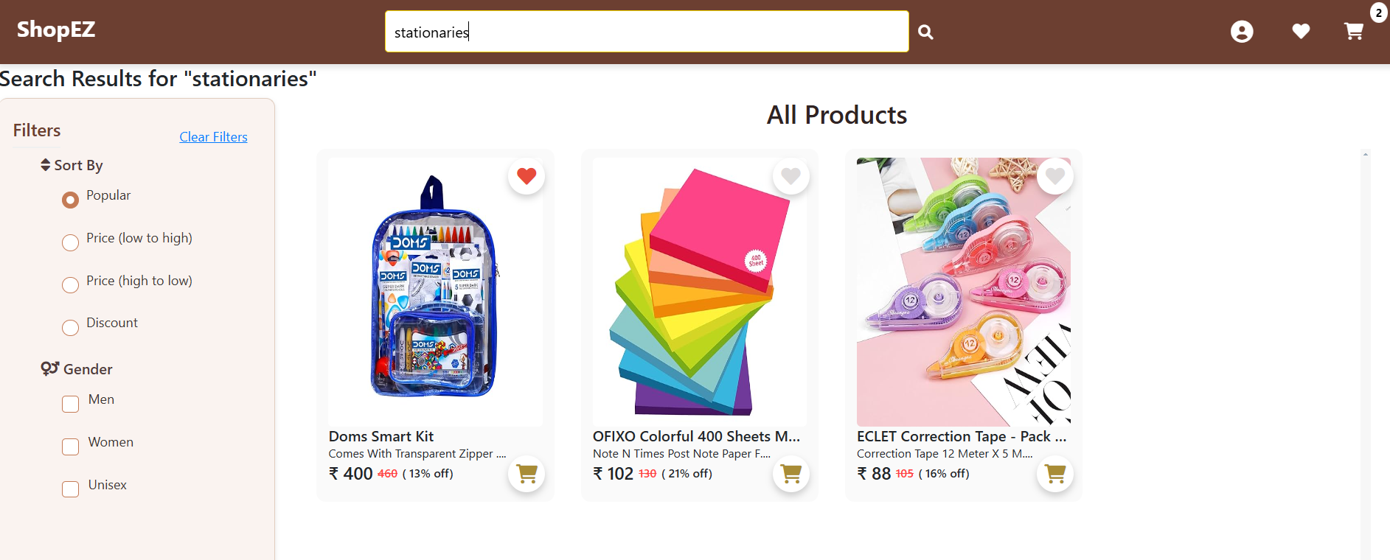

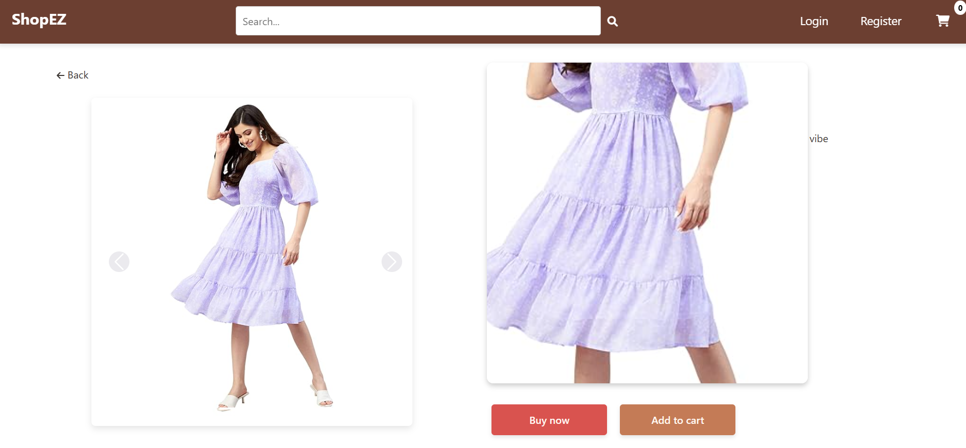

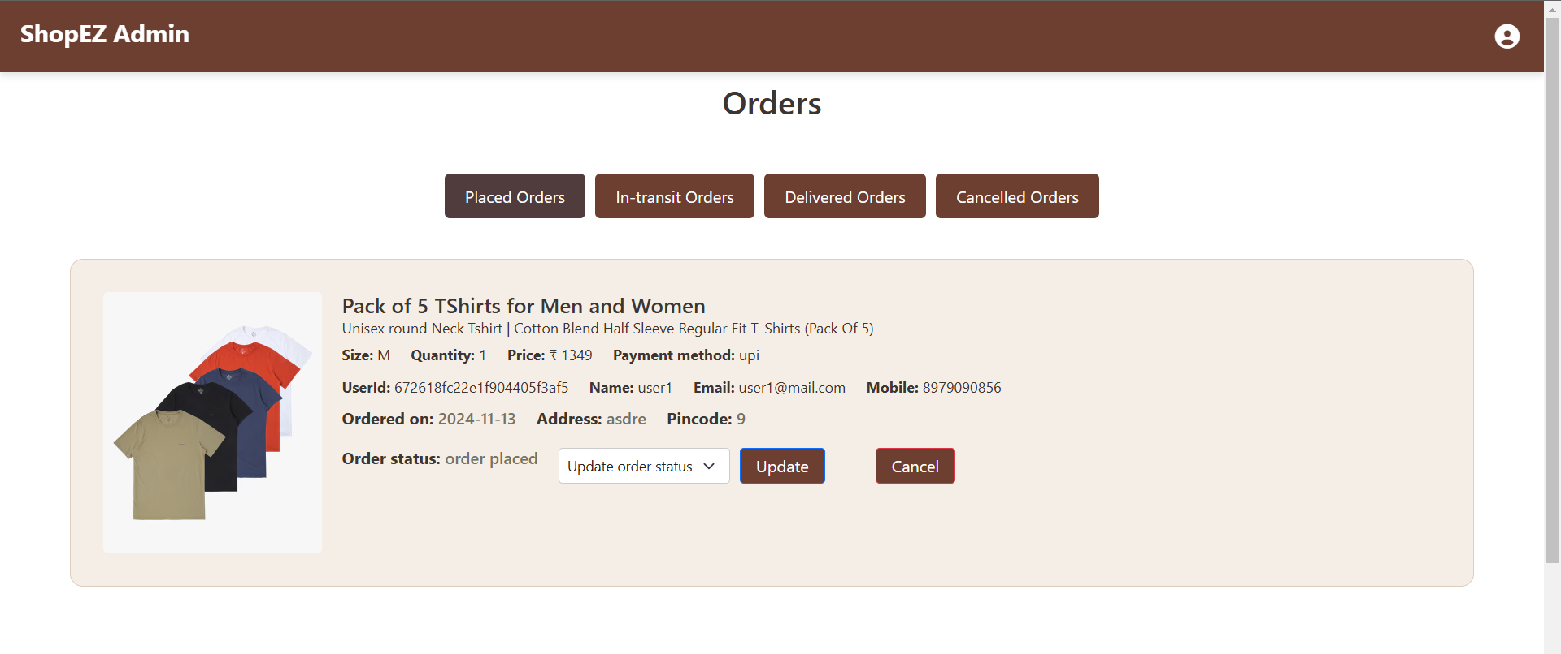

**10. TESTING**

The testing strategy for the ShopEZ e-commerce application focuses on ensuring the functionality, security, and performance of the application through API testing using Postman. Postman is utilized for testing the backend API endpoints and verifying the responses to ensure they meet expected behaviors.

1. **API Testing with Postman**:

* Postman is used to test all API endpoints, including user authentication, product management, order processing, and cart functionalities. Each endpoint is tested by sending various requests (GET, POST, PUT, DELETE) with different parameters to verify the accuracy and correctness of the responses.
* Authentication endpoints are tested by sending login credentials, checking for correct token generation, and validating token-based access control.
* Product-related endpoints (such as adding, updating, and retrieving products) are tested to ensure the correct flow of data and proper error handling.
* Order and cart management endpoints are also tested to ensure that actions such as adding items to the cart, placing orders, and updating order status are functioning correctly.

1. **Error Handling and Validation**:

* Responses are tested for proper status codes (200, 400, 401, 404, etc.), ensuring that the system handles errors correctly and returns appropriate messages when invalid data is sent or when users try to access restricted resources without proper authorization.
* Test cases are designed to cover both positive and negative scenarios, such as valid inputs and edge cases like missing or incorrect parameters.

1. **Test Automation and Repeatability**:

* Postman collections are used to automate and group tests, allowing for easy repeatability of test cases.
* This ensures consistency when validating changes made to the application.

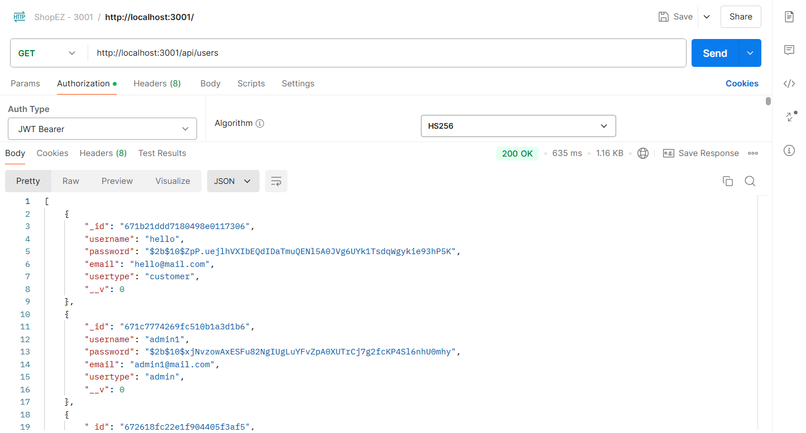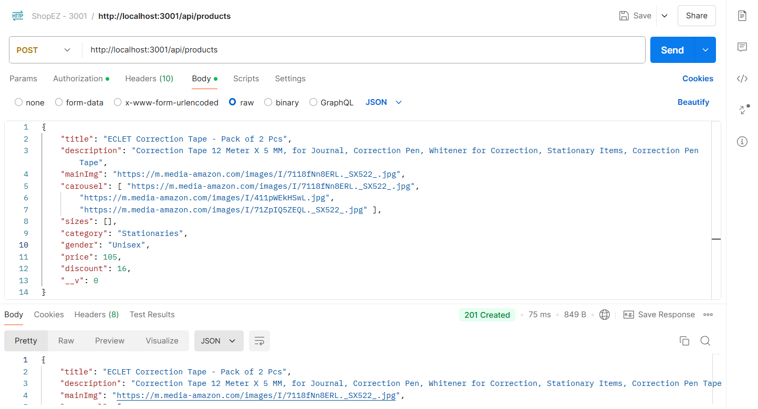

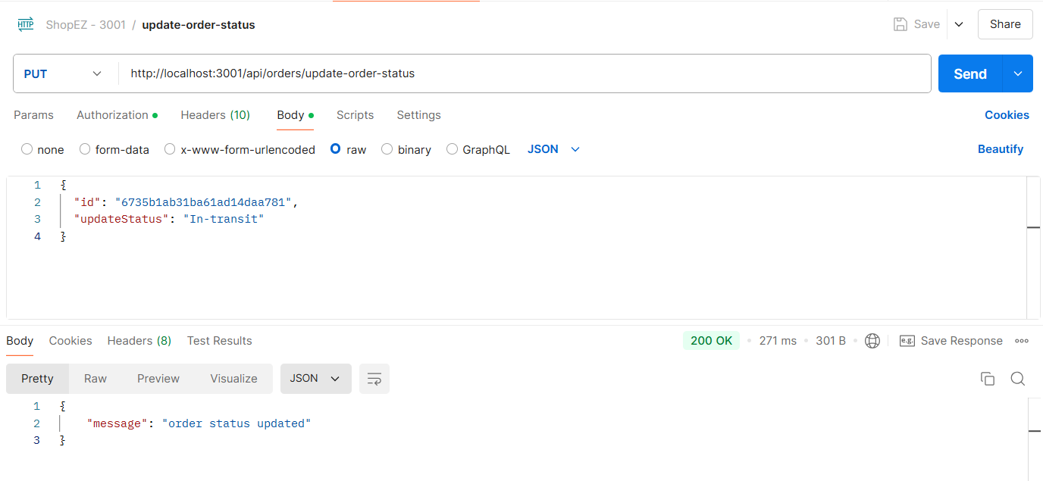

**11. SCREENSHOTS OR DEMO**

**Home page**

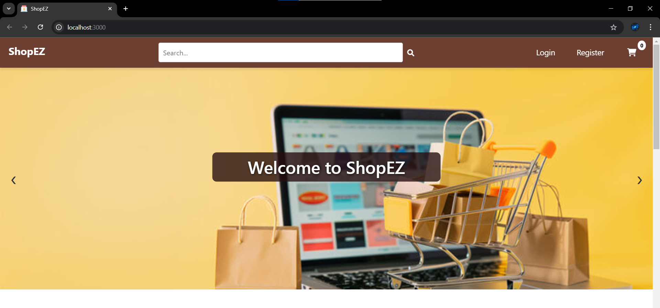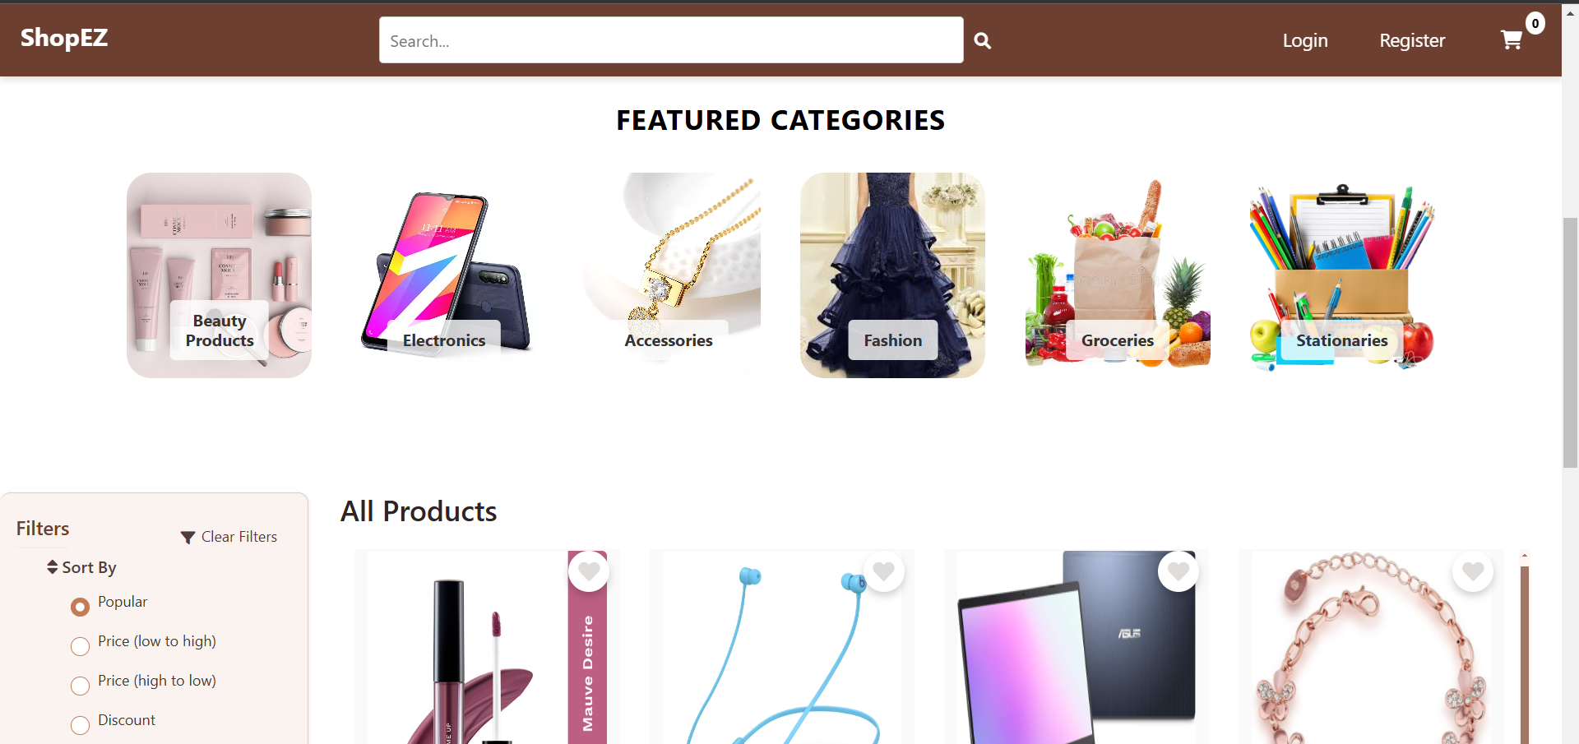

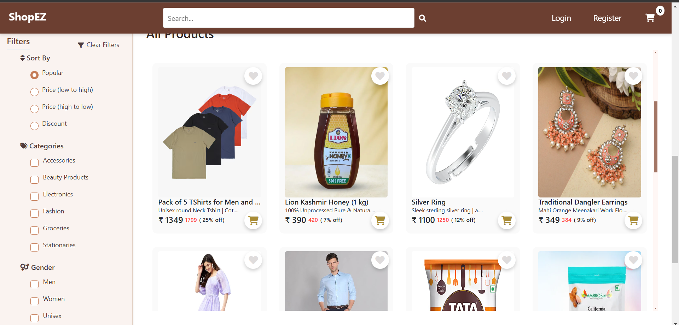

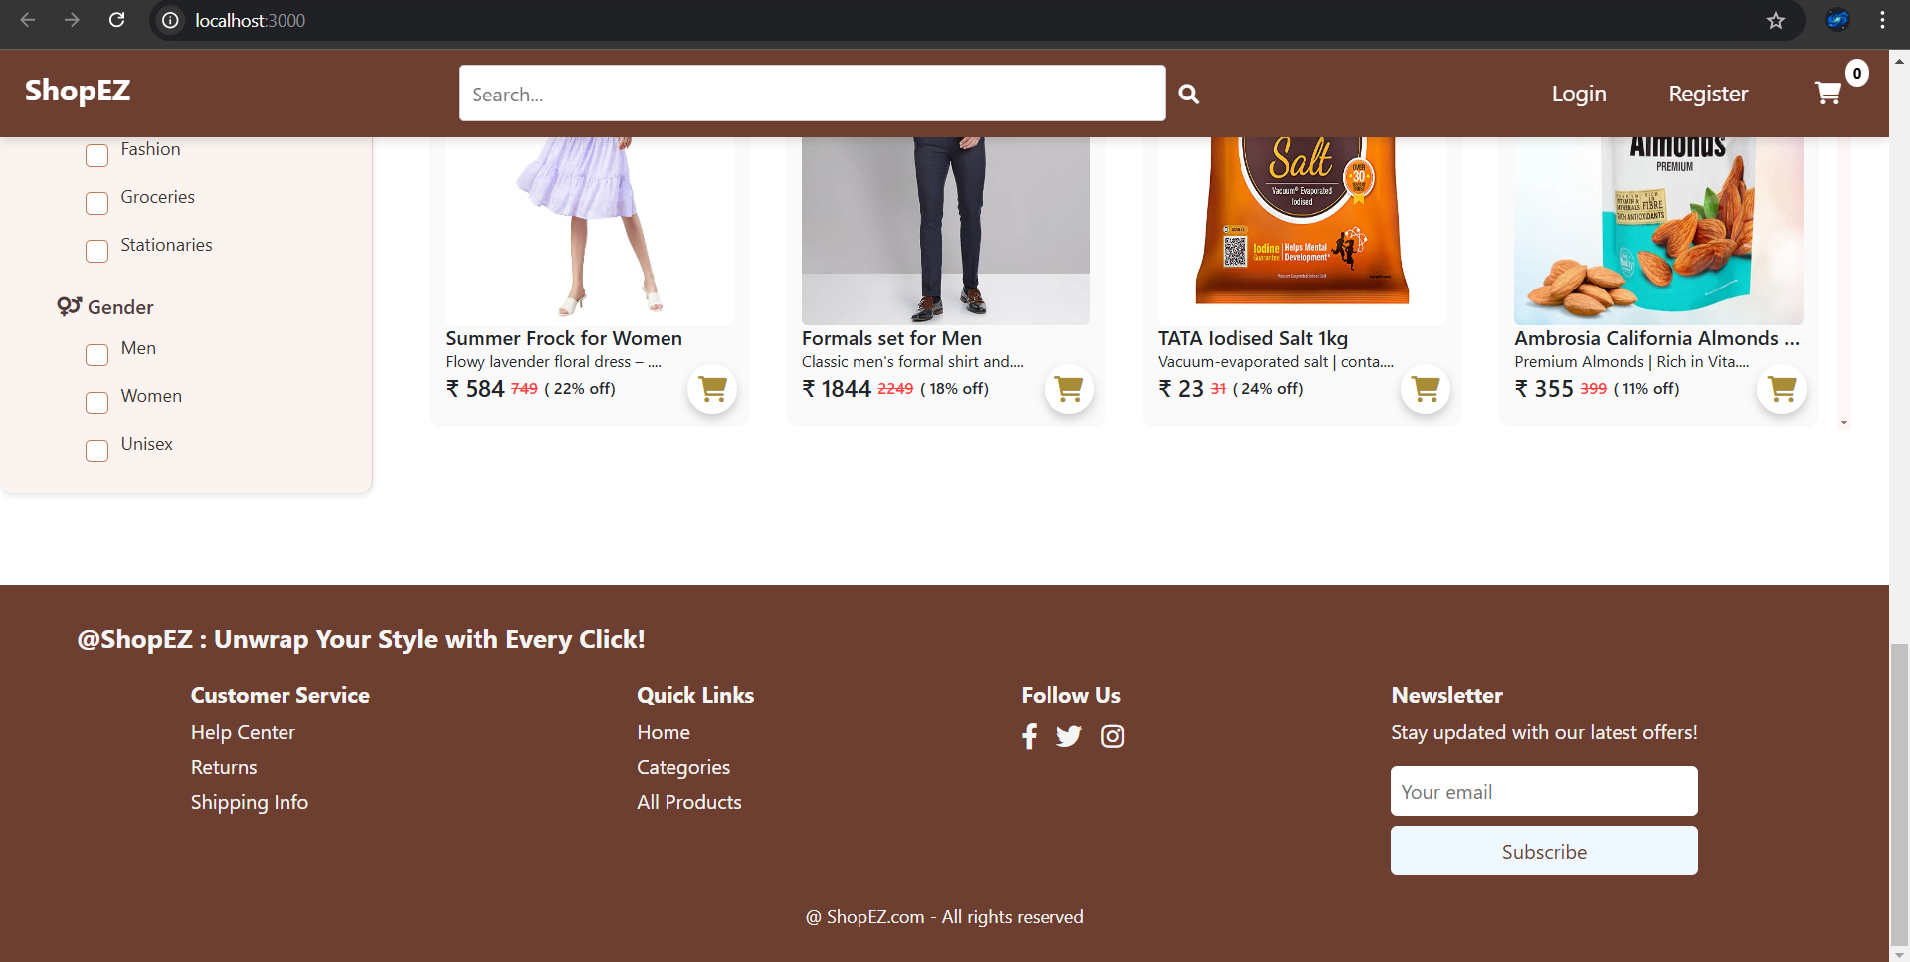

**Authentication**

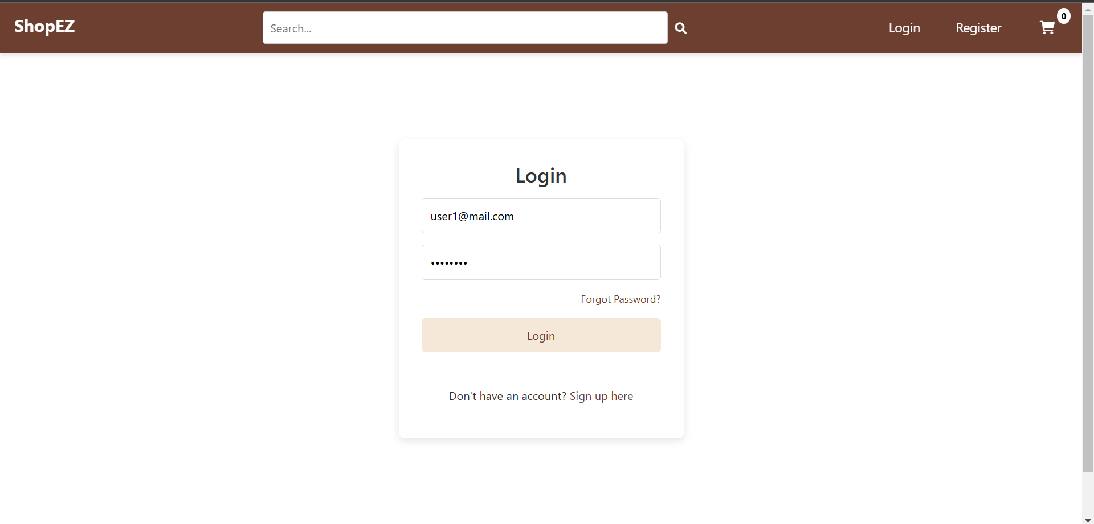

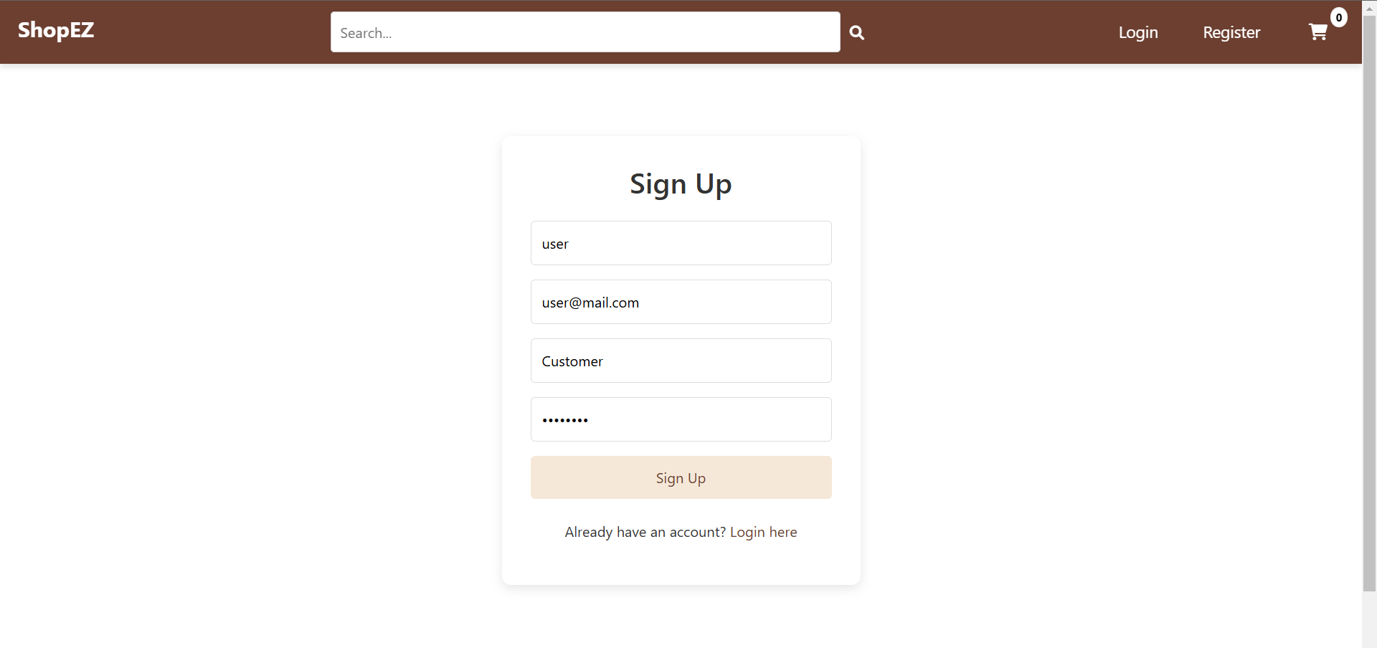

**Individual Products**

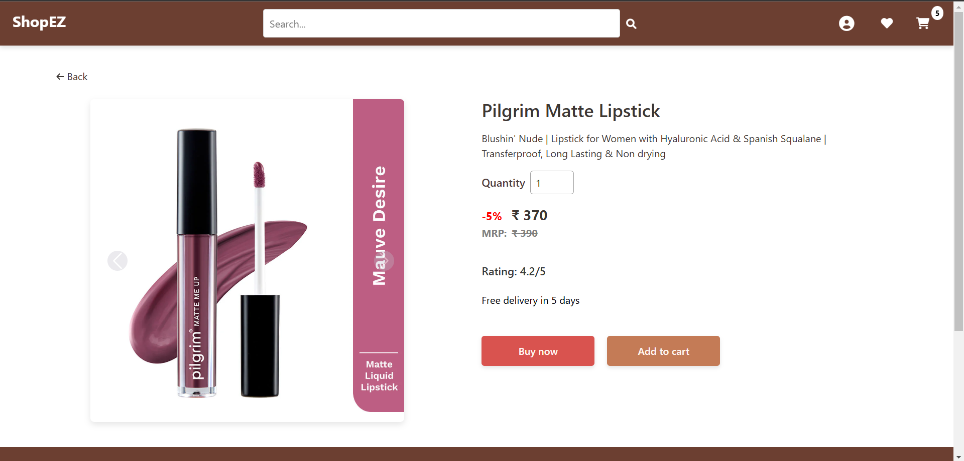

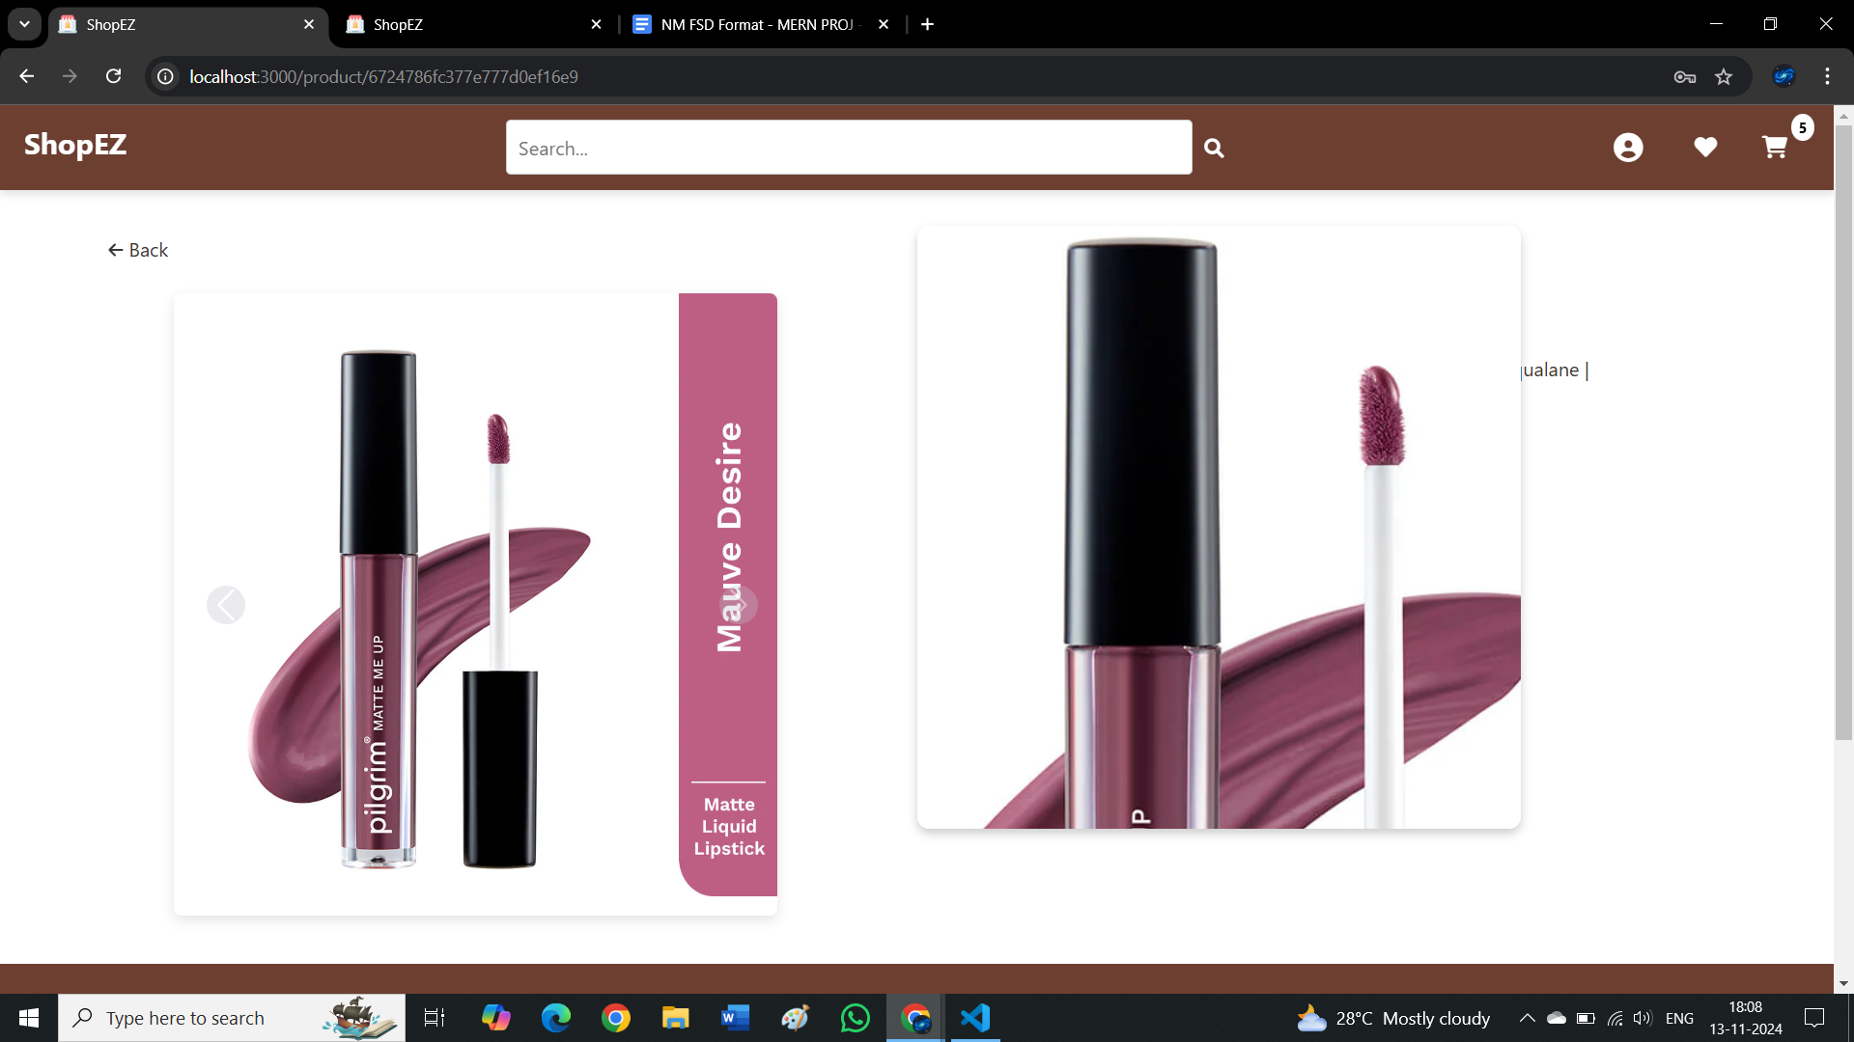

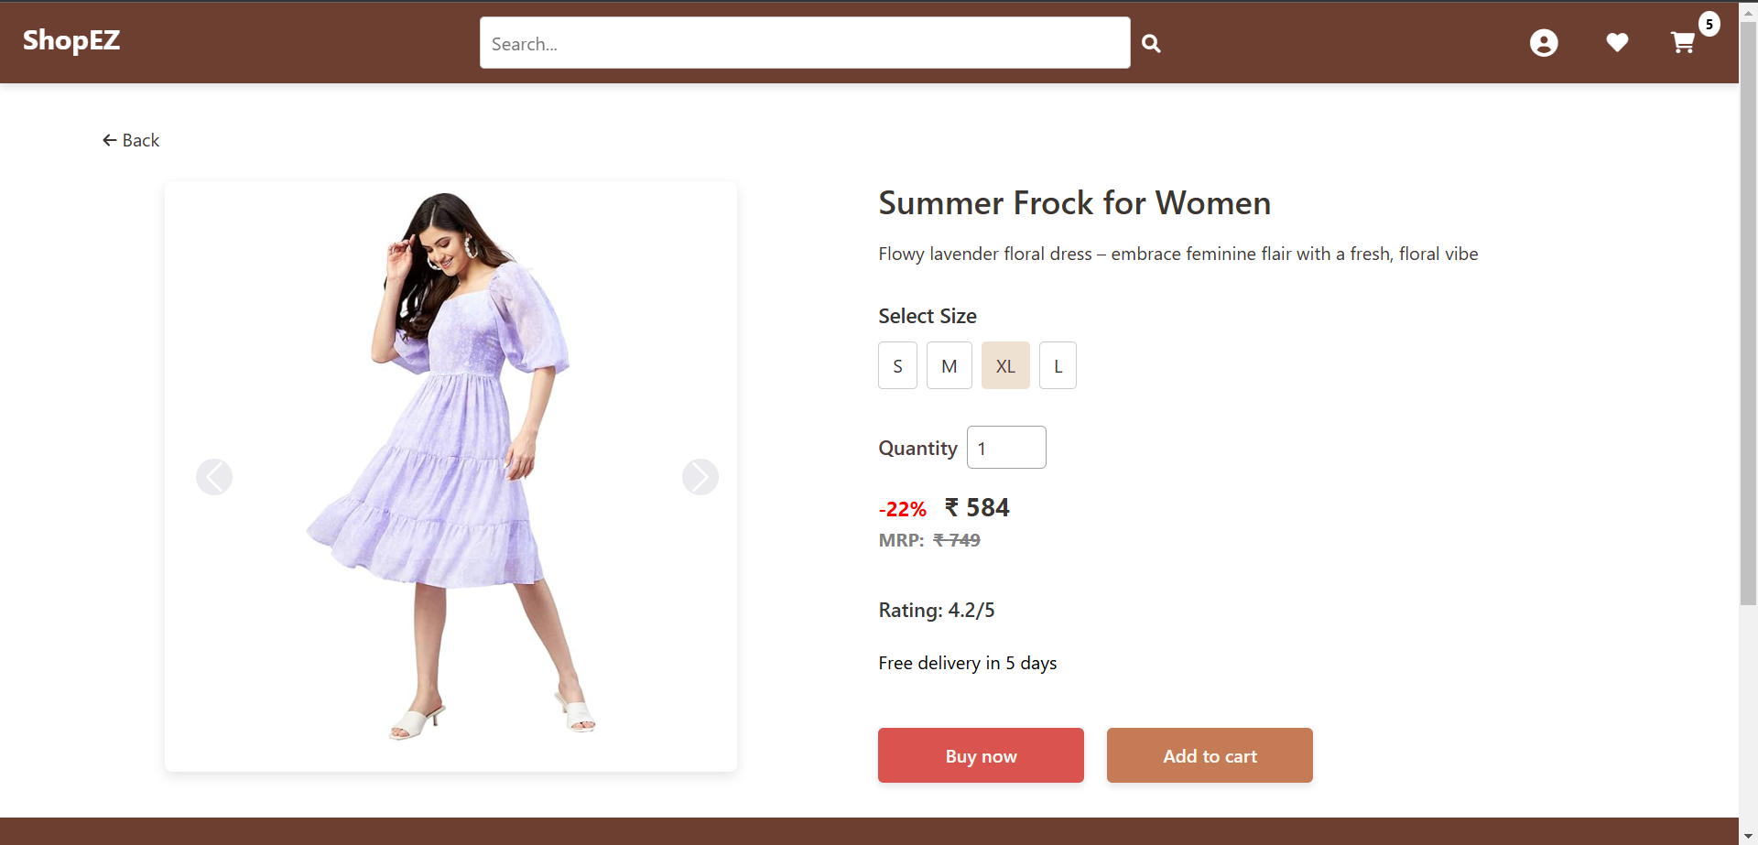

**Product Checkout**

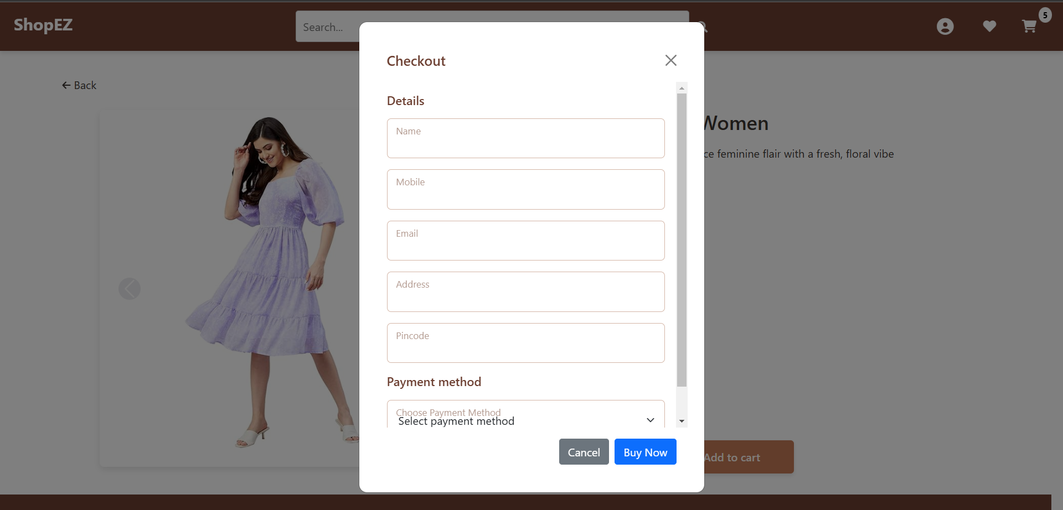

**Cart**

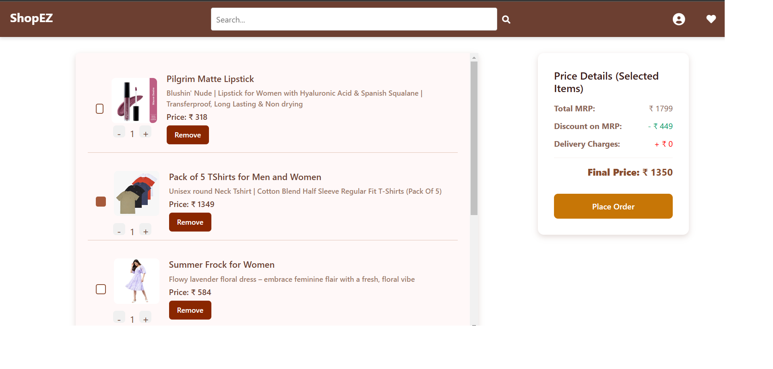

**User Profile**

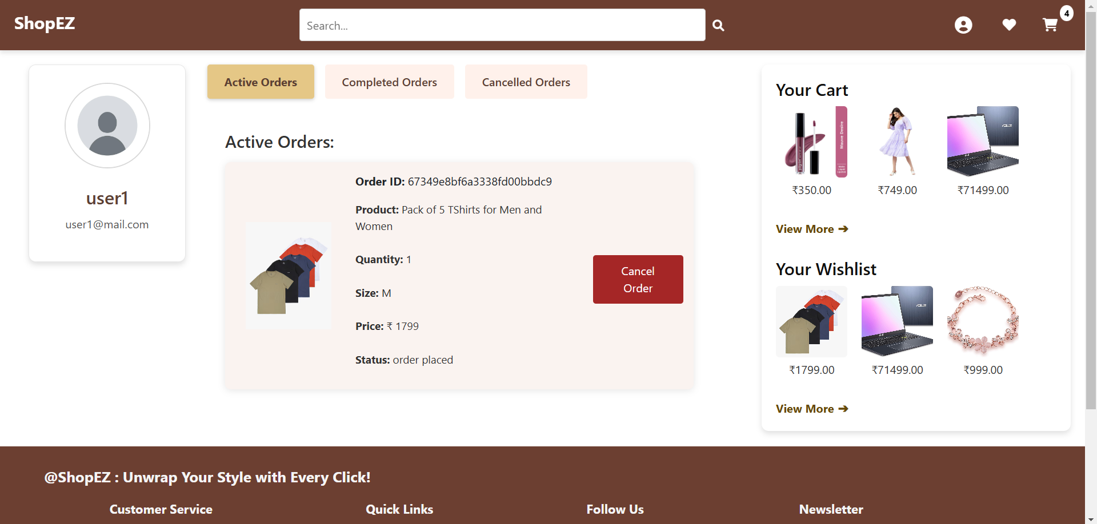

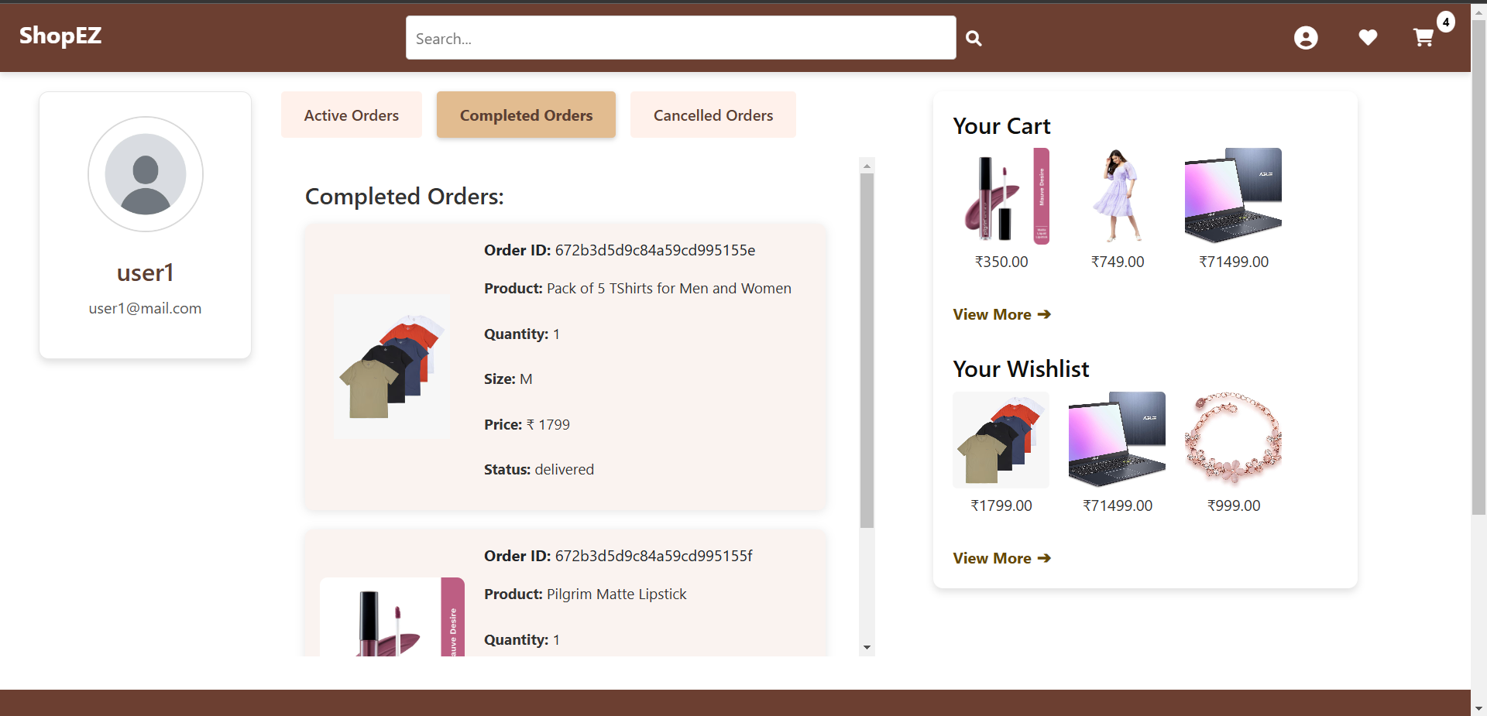

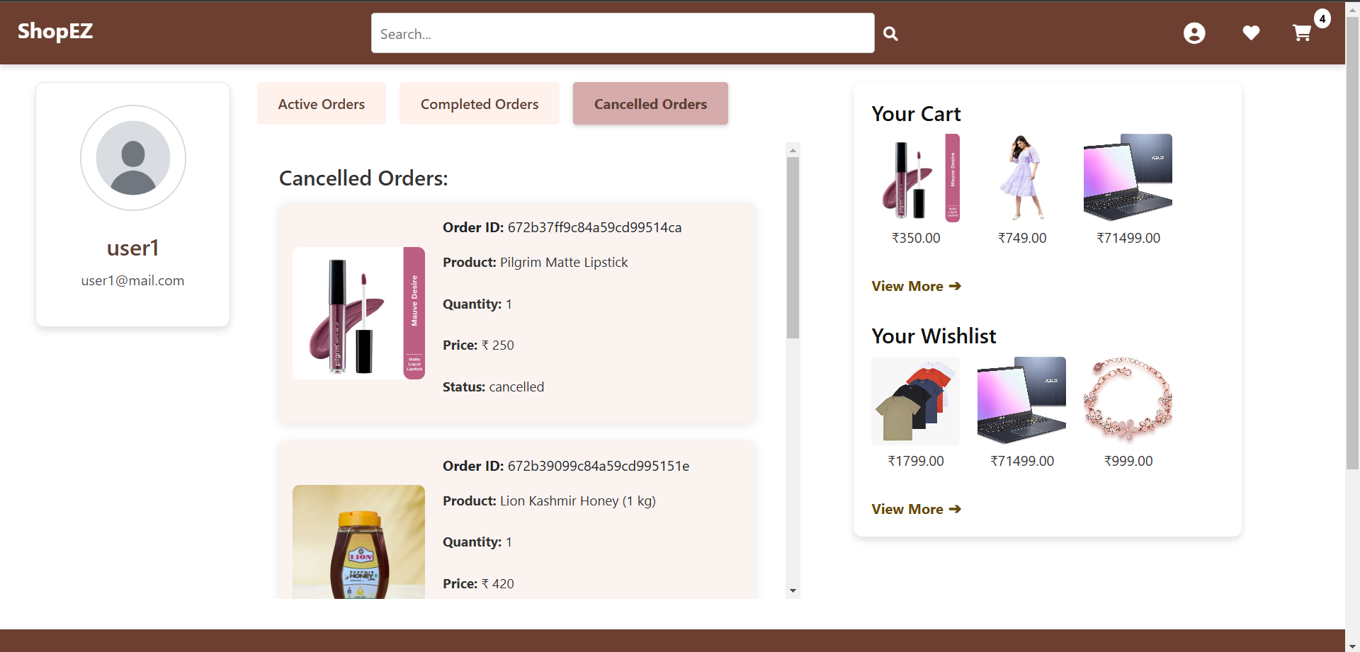

**Wishlist**

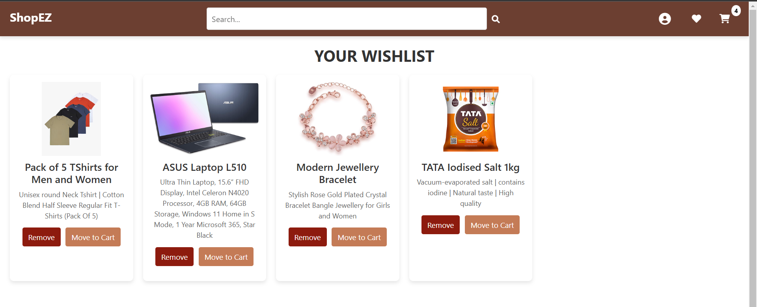

**Search**

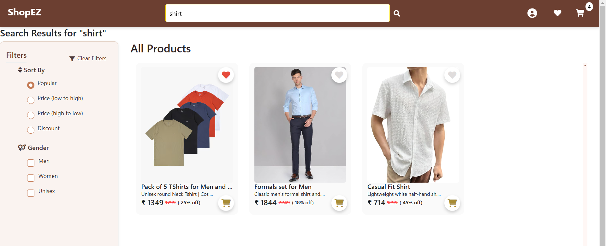

**Admin Dashboard**

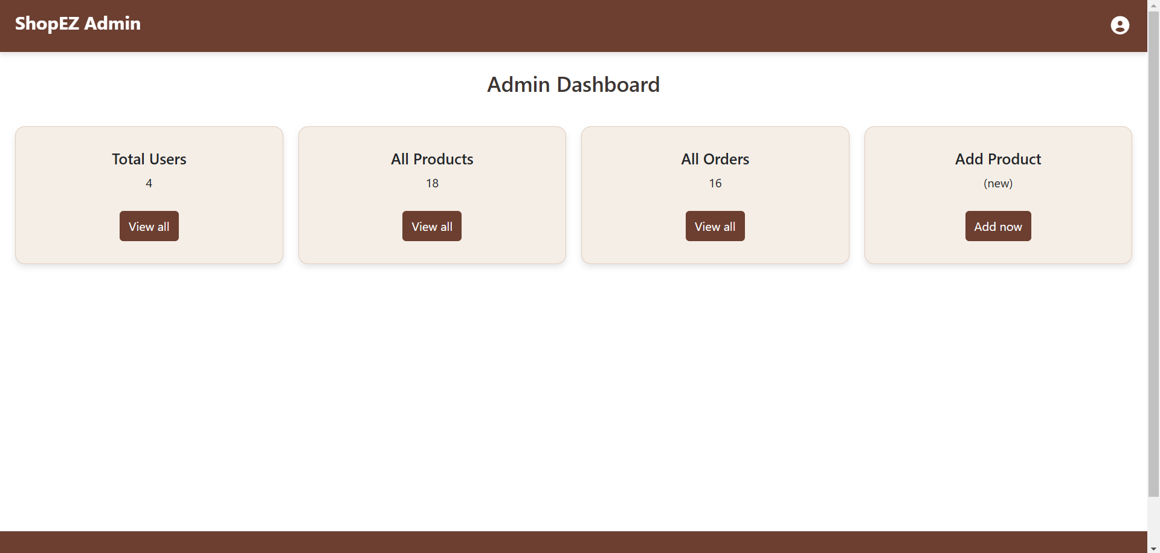

**All users**

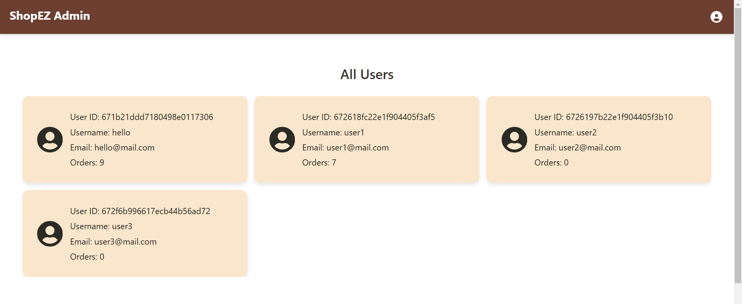

**All Orders**



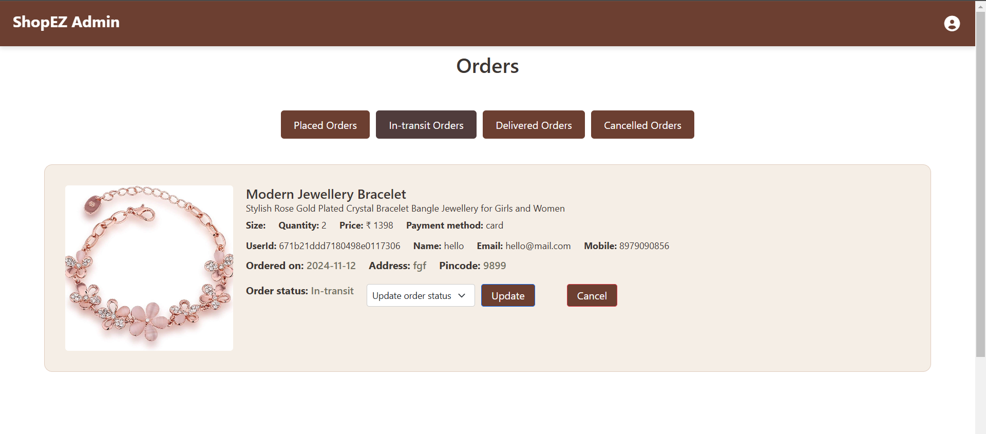

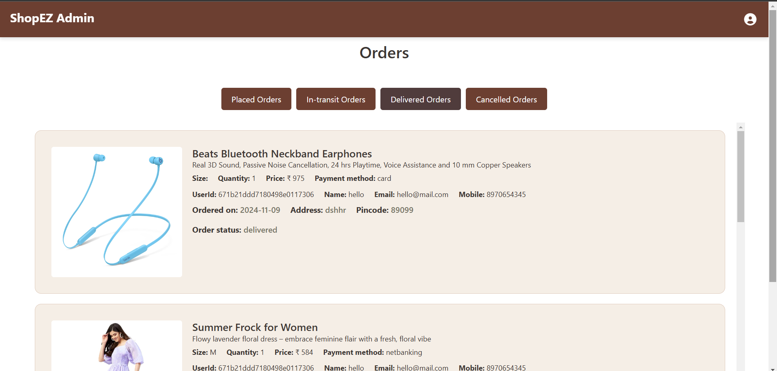

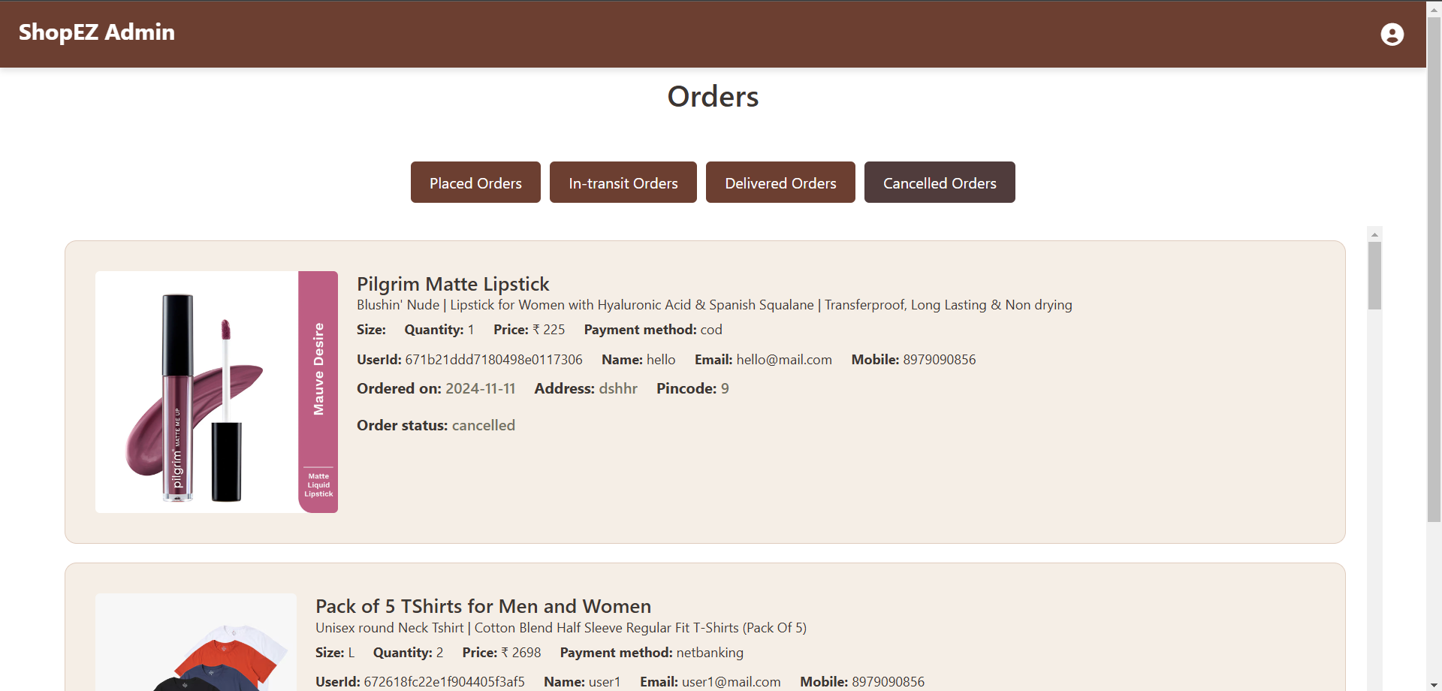

**All Products**

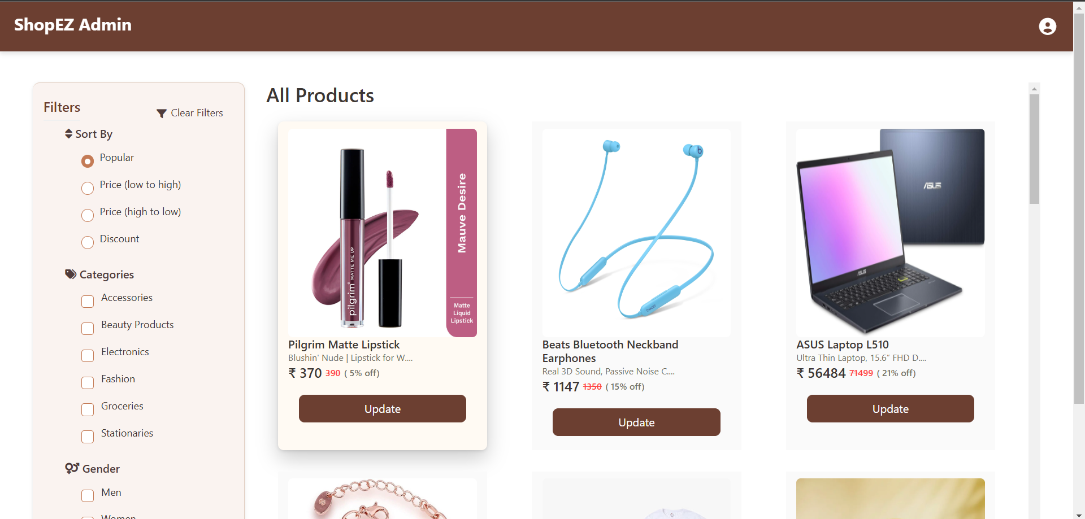

**Update Products**

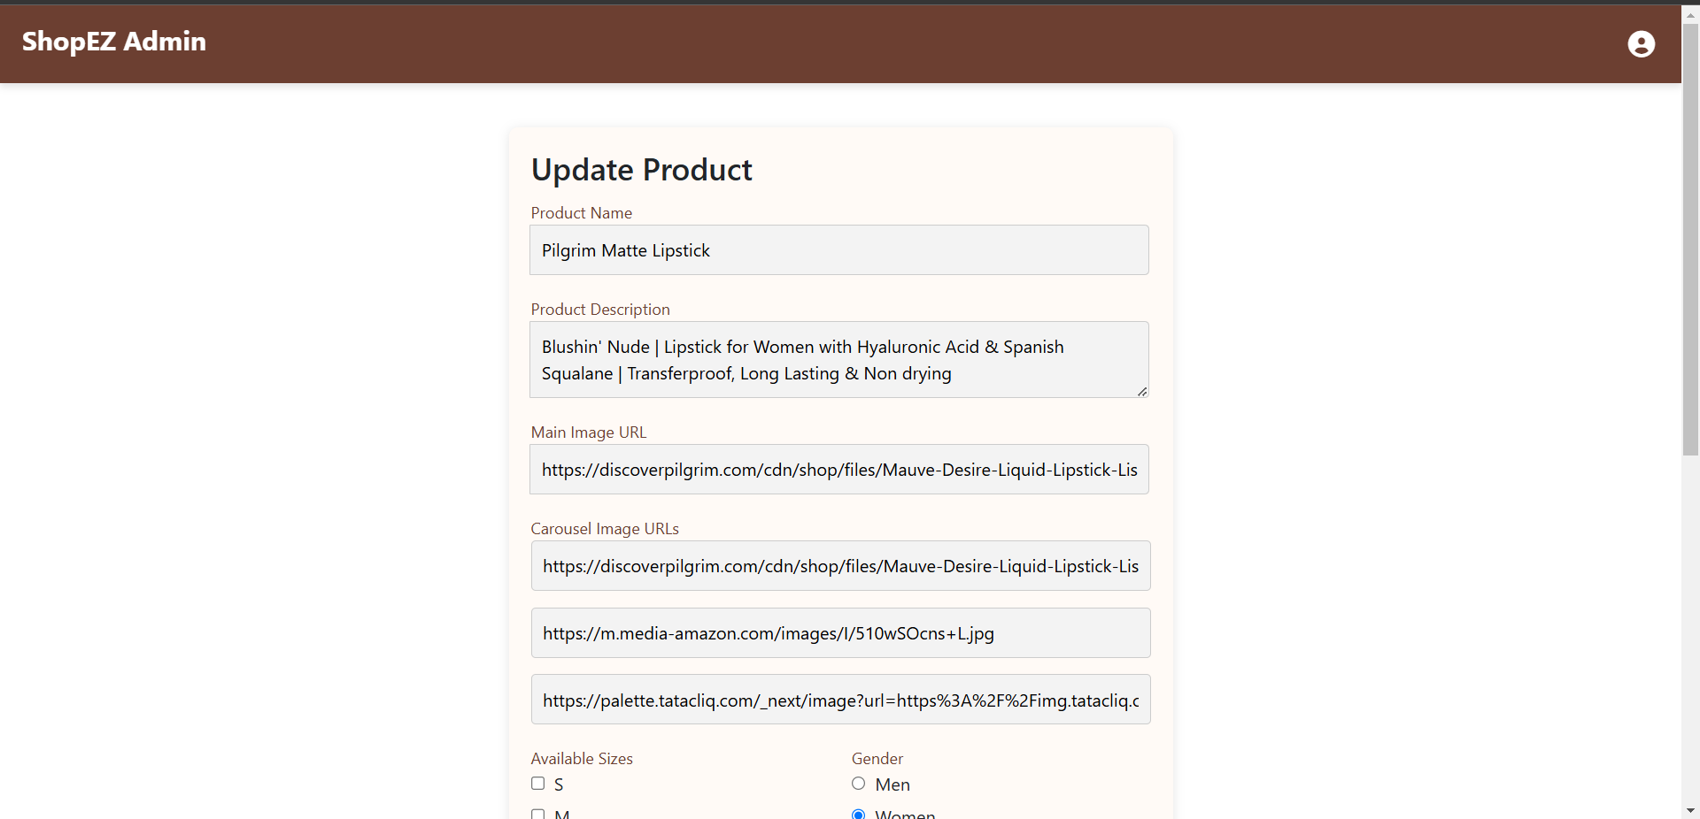

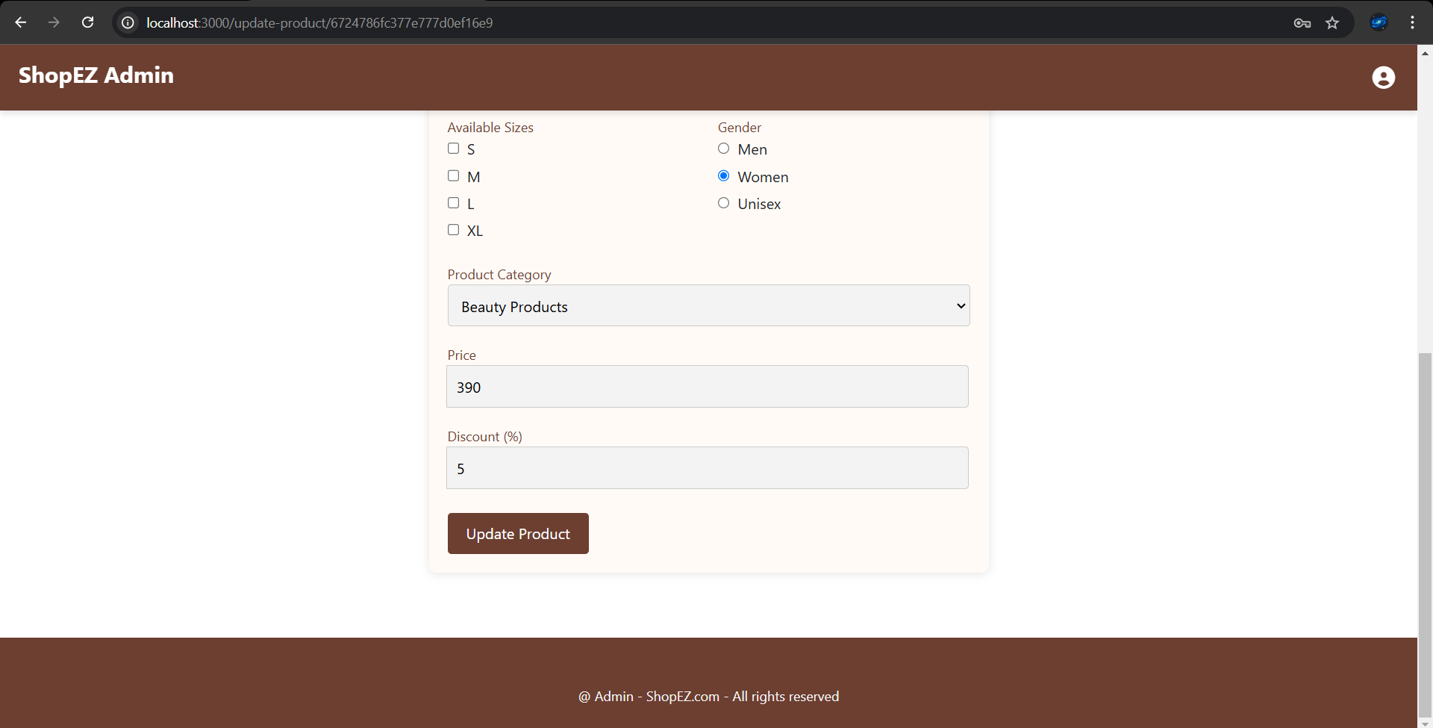

**Add New Products**

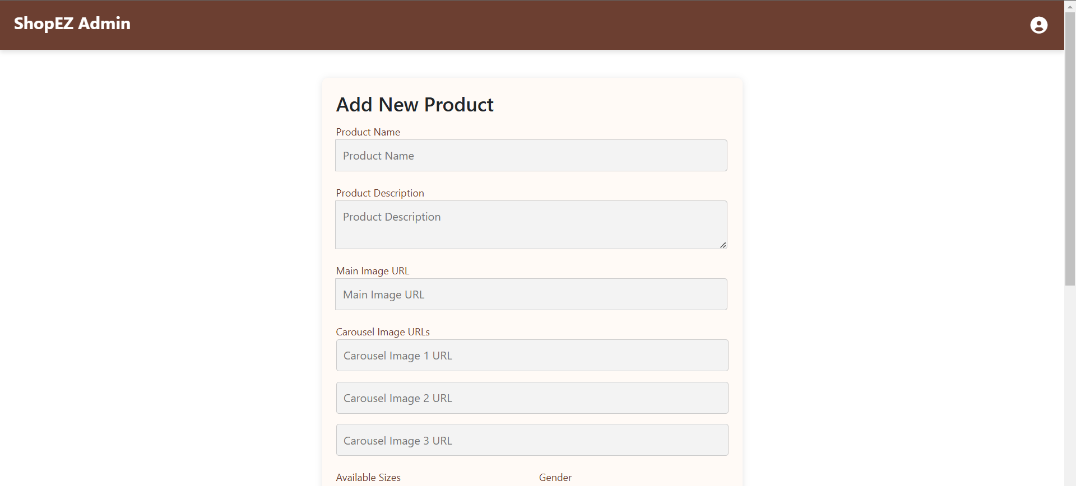

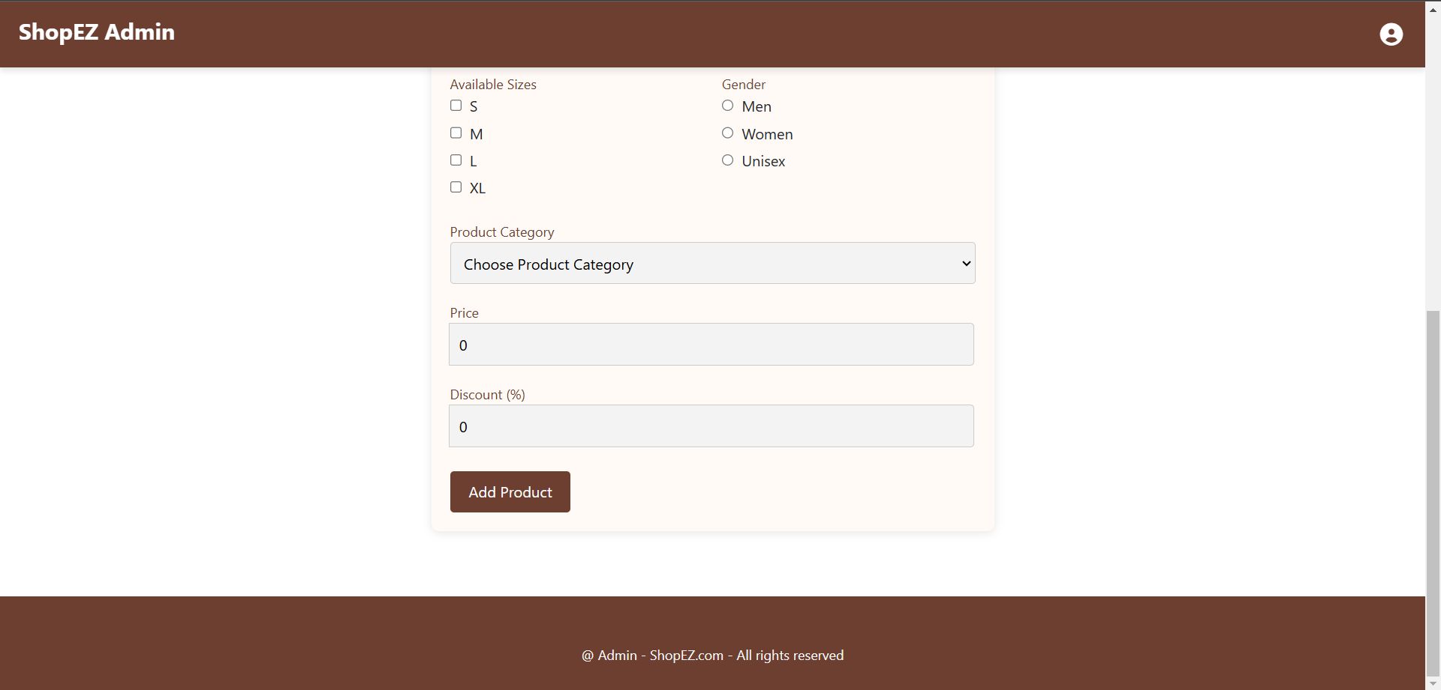

**Demo Video Link :** [ShopEZ demo.mp4](https://drive.google.com/file/d/1Jb7d1SN6HxgXltrtZ5N8u4vYwXsfyX52/view)

**12. KNOWN ISSUES**

1. **Forgot Password Functionality**:

* **Description**: The forgot password functionality does not currently include a verification step to confirm the validity of the email address before proceeding with the password reset process.
* **Impact**: If a user mistypes their email address, they will not receive any feedback, potentially leading to confusion as the reset link may not reach them.

1. **Cross-browser Compatibility**:

* **Description**: Certain features, like the image carousel and zoom functionality, may not display or function properly in all browsers, particularly older versions of Internet Explorer or Safari.
* **Impact**: Users on specific browsers may encounter layout or functionality issues, resulting in a suboptimal experience.

1. **Mobile Responsiveness**:

* **Description**: Some pages, including the Admin Dashboard and All Products view, may not be fully responsive on smaller devices or screens.
* **Impact**: Mobile users may experience issues with page alignment, layout, or broken UI components when accessing the app on smaller screens.

1. **Authentication Token Expiry Handling**:

* **Description**: The system does not consistently handle token expiry, which may lead to users staying logged in after their session expires or requiring a manual refresh to reauthenticate.
* **Impact**: Users may experience inconsistencies in session management, such as being logged out unexpectedly or having difficulty accessing features after token expiry.

1. **Admin Product Update Issues**:

* **Description**: After updating product details (e.g., price, description), the changes may not be immediately reflected in the Customer view.
* **Impact**: Admins may find that the updates are not visible right away, potentially causing delays or confusion during product management.

These issues are being actively worked on and will be addressed in future updates to improve the overall user experience and functionality.

**13. FUTURE ENHANCEMENTS**

* **Marketplace Integration:** Future versions of ShopEZ could include third-party seller integration, allowing external vendors to list products, thereby expanding the platform’s product offerings and increasing customer variety.
* **AI-Driven Personalization:** Incorporating AI to provide personalized product recommendations based on user behavior, preferences, and purchase history could enhance customer satisfaction and boost sales.
* **Augmented Reality (AR) Features:** Integrating AR technology could allow users to virtually "try" products such as fashion items or home decor, improving the shopping experience and reducing return rates.
* **Subscription-Based Models:** Offering subscription services for recurring purchases (e.g., groceries, beauty products) would create steady revenue streams and increase customer loyalty.
* **Global Expansion**: The platform could expand its reach to global markets by adding multi-language and multi-currency support, making it accessible to a broader customer base.
* **Advanced Analytics for Admins:** Providing more detailed analytics and insights for admins—such as customer sentiment analysis, predictive inventory management, and sales forecasting—could further enhance decision-making and operational efficiency.
* **Sustainability Initiatives:** Introducing eco-friendly product lines and promoting sustainable shopping practices could resonate well with environmentally-conscious consumers, positioning ShopEZ as a socially responsible brand.

**CONCLUSION**

In conclusion, ShopEZ is a comprehensive e-commerce platform designed to provide a seamless, user-friendly experience for customers and efficient management tools for administrators. The project successfully integrates key features such as personalized shopping experiences, real-time order tracking, and an intuitive admin dashboard. By utilizing a robust technology stack and ensuring a focus on scalability and performance, ShopEZ aims to meet the growing demands of the e-commerce market. Its design prioritizes security, customer retention, and mobile-first accessibility, positioning it as a reliable and efficient online shopping platform.

**GITHUB LINK:** [ShopEZ Github](https://github.com/Gayathri2505/ShopEZ-Naan-Mudhalvan.git)